**CHAPTER 1**

**INTRODUCTION**

**1.1PROBLEM DEFINITION**

InvestoAvenue is a specialist wealth handling firm that is focused towards personalized financial advisory, thus catering to the asset management requirements of its clients. Financial advices provided by InvestoAvenue is based on understanding the client’s present and future cash flows and financial objectives.

The application should incorporate a user-friendly design and help InvestoAvenue’s business by allowing clients to provide their financial details. Clients should be allowed to register and create their own profiles in order to seek financial guidance. The application should employ an analytical algorithm, that would suggest the best investment and financial plans, as per the details provided by the clients. Payment should be accepted categorically based on the services provided

The application that contain all the details about the firm and its business history. The application allows the user to register and login the customer by using their own username and password. Mainly the application concentrate on three type of users ,they are Individual, Medium Scale Industries and Corporates.

The application should incorporate an analytical algorithm that would suggest the clients a list of the most appropriate investment options based on the various parameters/information provided by the clients. It should allow payment of the specified charges for the services availed. It should allow clients to rate the application and provide a feedback on its performance. Also It should pick the best positive reviews written by the registered clients and display them on the homepage.

**1.2 ABOUT THE ORGANIZATION**

Infosys was established by seven engineers in Pune, Maharashtra, India with an initial capital of $250 in 1981. It was registered as Infosys Consultants Private Limited on 2 July 1981. In 1983, it relocated its office to Bangalore, Karnataka, India.

Infosys Ltd is a global technology services firm that defines, designs and delivers information technology (IT)-enabled business solutions to their clients. The company provides end-to-end business solutions that leverage technology for their clients, including technical consulting, design, development, product engineering, maintenance, systems integration, package-enabled consulting, and implementation and infrastructure management services.

The company also provides software products to the banking industry. They have developed Finacle, a universal banking solution to large and medium size banks across India and overseas. Infosys BPO is a majority owned subsidiary. Through Infosys BPO, the company provides business process management services, such as offsite customer relationship management, finance and accounting, and administration and sales order processing. The company is having marketing and technical alliance with FileNet, IBM, Intel, Microsoft, Oracle and System Application Products.

Infosys Ltd is a public limited and India's second largest software exporter company was incorporated in the year 1981 as Infosys Consultants Pvt Ltd by Mr. N.R. Narayana Murthy at Karnataka. The company was started by seven people with the investment of USD 250. The company became a public limited company in the year 1992. The company was the first Indian company to be listed on the NASDAQ in the year 1999. Infosys also forms a part of the NASDAQ-100 index. Continuously in the year 2001, 2002 and 2003, the company wins the National award for excellence in corporate governance conferred by the Government of India.

* 1. **OBJECTIVE OF THE PROJECT**

INVESTOAVENUE is a wealth handling firm that will used to manage and controls the wealth of registered users. The application should help the registered user to control their income and expense.

The application allows two type of users to use the system. They are registered user and guest user. The registered user is the user he/she can explore the application by using all its advantages. When the user first use the system, then he/she will be a guest user. After once they registered in to the system then he/she will turn to as a registered user. Then he/she can login to the system using hi/her unique username and password.

Then he/she can enter all the details of their income and expenses in the form of asset, Liabilities, Expenses. After collecting all the data by using the algorithm the application should predict his/her most appropriate investment options. It will help them for future saving. Also it make some charges for the services.

In the case of a guest user he/she can only visit the website and view all the application provided by the firm. He/she cannot have the permission to get the financial advises.

**CHAPTER 2**

**LITERATURE SURVEY**

**2.1 INITIAL INVESTIGATION**

Now a days the handling of finance is one of the major problem faced by the peoples. Here we are try to make a solution for this problem. Now we collect all the requirements needed for developing our application. The collecting of requirements is one the major problem faced during the initial investigation. We need to collect the requirements in the form of user wishes.

For developing a prediction according to the users need we need to analyse the collected data from user. For this initially we want to train the system. During the initial investigation stage we try to train our system using a list of collected data. A CSV file is used to train the system. For the training purpose we collect a huge data in the form of a csv file.

Thus this system can reduce the manual effort a greater extend. The system has the following users.

* Guest User
* Registered User

A guest user is the user he/she has only provision to open the application and view only. On the other hand for a registered user he/she can use the system up to its limits.the registered user can have the provision to login, register ,add ,update ,view, report generation, payment, calculation.

Overall the project contain the following modules,

* Login
* Register
* View
* Add
* Update
* Report generation
* Payment
* Calculation

**2.2 EXISTING SYSTEM**

An initial investigation is conducted to know about the existing system. The main objective of this investigation is problem identification. Today the finance management is one of the main problem faced by the peoples. There are a number of application for managing the finance of the customer are available today. But its all take a lot of manual calculations and man power for generating the result.

**2.3 PROPOSED SYSTEM**

In our proposed system here we are try to implement a system which will used to manage the wealth of the customer. Here we provide permission to the registered customer to add their wealth details in the form of asset ,expense ,liabilities. By collecting all the details the system analyse the details with the help of machine learning algorithm. By using the trained data we classify the collected data to a particular category and provide the financial advices.

**Why MACHINE LEARNING?**

Machine learning (ML) is a field of artificial intelligence that uses statistical techniques to give computer systems the ability to learn from data, without being explicitly programmed. Machine learning explores the study and construction of algorithms that can learn from and make predictions on data such algorithms overcome following strictly static program instructions by making data-driven predictions or decisions, through building a model from sample inputs. Machine learning is employed in a range of computing tasks where designing and programming explicit algorithms with good performance is difficult or infeasible; example applications include email filtering, detection of network intruders, and computer vision.

Machine learning is closely related to computational statistics, which also focuses on prediction-making through the use of computers. It has strong ties to mathematical optimization, which delivers methods, theory and application domains to the field. Machine learning is sometimes conflated with data mining, where the latter subfield focuses more on exploratory data analysis and is known as unsupervised learning.

Within the field of data analytics, machine learning is a method used to devise complex models and algorithms that lend themselves to prediction; in commercial use, this is known as [predictive analytics](https://en.wikipedia.org/wiki/Predictive_analytics). These analytical models allow researchers, [data scientists](https://en.wikipedia.org/wiki/Data_science), engineers, and analysts to produce reliable, repeatable decisions and results and uncover hidden insights through learning from historical relationships and trends in the data.

The process of learning begins with observations or data, such as examples, direct experience, or instruction, in order to look for patterns in data and make better decisions in the future based on the examples that we provide. **The primary aim is to allow the computers learn automatically** without human intervention or assistance and adjust actions accordingly.

Machine learning algorithms are often categorized as supervised or unsupervised. **Supervised machine learning algorithms**can apply what has been learned in the past to new data using labeled examples to predict future events. Starting from the analysis of a known training dataset, the learning algorithm produces an inferred function to make predictions about the output values. The system is able to provide targets for any new input after sufficient training. The learning algorithm can also compare its output with the correct, intended output and find errors in order to modify the model accordingly.

In contrast, **unsupervised machine learning algorithms**are used when the information used to train is neither classified nor labeled. Unsupervised learning studies how systems can infer a function to describe a hidden structure from unlabeled data. The system doesn’t figure out the right output, but it explores the data and can draw inferences from datasets to describe hidden structures from unlabeled data.

**Semi-supervised machine learning algorithms** fall somewhere in between supervised and unsupervised learning, since they use both labeled and unlabeled data for training – typically a small amount of labeled data and a large amount of unlabeled data. The systems that use this method are able to considerably improve learning accuracy. Usually, semi-supervised learning is chosen when the acquired labeled data requires skilled and relevant resources in order to train it / learn from it. Otherwise, acquiring unlabeled data generally doesn’t require additional resources.

**Reinforcement machine learning algorithms**is a learning method that interacts with its environment by producing actions and discovers errors or rewards. Trial and error search and delayed reward are the most relevant characteristics of reinforcement learning. This method allows machines and software agents to automatically determine the ideal behavior within a specific context in order to maximize its performance. Simple reward feedback is required for the agent to learn which action is best; this is known as the reinforcement signal.

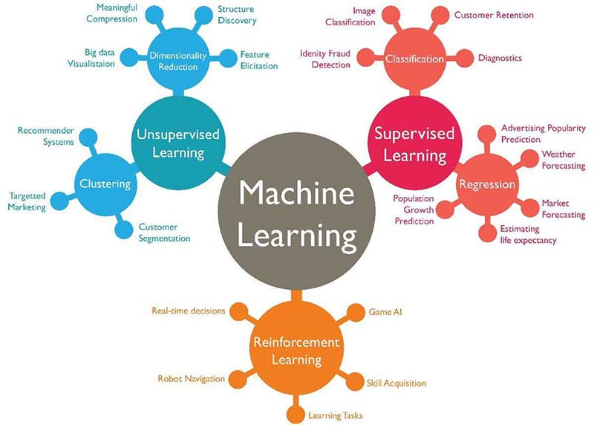

Figure 1 : Machine Learning Algorithms

Machine learning enables analysis of massive quantities of data. While it generally delivers faster, more accurate results in order to identify profitable opportunities or dangerous risks, it may also require additional time and resources to train it properly. Combining machine learning with AI and cognitive technologies can make it even more effective in processing large volumes of information

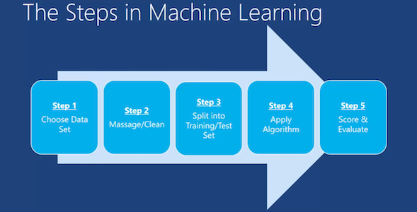

Figure 2 : Machine Learning Steps

# APPLICATIONS OF MACHINE LEARNING

Artificial Intelligence (AI) is everywhere. Possibility is that you are using it in one way or the other and you don’t even know about it. One of the popular applications of AI is Machine Learning (ML), in which computers, software, and devices perform via cognition (very similar to human brain).

1.**Virtual Personal Assistants**

Siri, Alexa, Google Now are some of the popular examples of virtual personal assistants. As the name suggests, they assist in finding information, when asked over voice. The personal assistant looks out for the information, recalls your related queries, or send a command to other resources (like phone apps) to collect info and can even instruct assistants for certain tasks.

Machine learning is an important part of these personal assistants as they collect and refine the information on the basis of your previous involvement with them. Later, this set of data is utilized to render results that are tailored to your preferences.

Virtual Assistants are integrated to a variety of platforms. For example:

* Smart Speakers: Amazon Echo and Google Home
* Smartphones: Samsung Bixby on Samsung S8
* Mobile Apps: Google Allo

**2. Predictions while Commuting**

*Traffic Predictions*: While we use GPS navigation services, the current locations and velocities are being saved at a central server for managing traffic. This data is then used to build a map of current traffic. While this helps in preventing the traffic and does congestion analysis, the underlying problem is that there are less number of cars that are equipped with GPS. Machine learning in such scenarios helps to estimate the regions where congestion can be found on the basis of daily experience.

*Online Transportation Networks*: When booking a cab, the app estimates the price of the ride. When sharing these services, they minimize the detours by machine learning. Jeff Schneider, the engineering lead at Uber ATC reveals in an interview that they use ML to define price surge hours by predicting the rider demand. In the entire cycle of the services, ML is playing a major role.

**3. Videos Surveillance**

The video surveillance system nowadays is powered by AI that makes it possible to detect crime before they happen. They track unusual behavior of people like standing motionless for a long time, stumbling, or napping on benches etc. The system can thus give an alert to human attendants, which can ultimately help to avoid mishaps. And when such activities are reported and counted to be true, they help to improve the surveillance services. This happens with machine learning doing its job at the backend.

**4. Social Media Services**

From personalizing the news feed to better ads targeting, social media platforms are utilizing machine learning for their own and user benefits.

*People You May Know*: Machine learning works on a simple concept: understanding with experiences. Facebook continuously notices the friends that users connect with, the profiles that users visit very often, interests, workplace, or a group that users share with someone etc.

* *Face Recognition*: Users upload a picture of with a friend and Facebook instantly recognizes that friend. Facebook checks the poses and projections in the picture, notice the unique features, and then match them with the people in the friend list. The entire process at the backend is complicated and takes care of the precision factor but seems to be a simple application of ML at the front end.
* *Similar Pins*: Machine learning is the core element of Computer Vision, which is a technique to extract useful information from images and videos. Pinterest uses computer vision to identify the objects (or pins) in the images and recommend similar pins accordingly.

**5. Email Spam and Malware Filtering**

* There are a number of spam filtering approaches that email clients use. To ascertain that these spam filters are continuously updated, they are powered by machine learning. When rule-based spam filtering is done, it fails to track the latest tricks adopted by spammers. Multi-Layer Perceptron, C 4.5 Decision Tree Induction are some of the spam filtering techniques that are powered by ML.
* Over 325, 000 malwares are detected every day and each piece of code is 90–98% similar to its previous versions. The system security programs that are powered by machine learning understand the coding pattern. Therefore, they detect new malware with 2–10% variation easily and offer protection against them.

**6. Online Customer Support**

A number of websites nowadays offer the option to chat with customer support representative while they are navigating within the site. However, not every website has a live executive to answer the queries. In most of the cases, users talk to a chatbot. These bots tend to extract information from the website and present it to the customers. Meanwhile, the chatbots advances with time. They tend to understand the user queries better and serve them with better answers, which is possible due to its machine learning algorithms.

**7. Search Engine Result Refining**

Google and other search engines use machine learning to improve the search results for users. Every time users execute a search, the algorithms at the backend keep a watch at how users respond to the results. If the particular user opens the top results and stay on the web page for long, the search engine assumes that the results it displayed were in accordance to the query. Similarly, if the user reaches the second or third page of the search results but do not open any of the results, the search engine estimates that the results served did not match requirement. This way, the algorithms working at the backend improve the search results.

**8. Product Recommendations**

The users shopped for a product online and then users keep receiving emails for shopping suggestions. If not this, then users might have noticed that the shopping website or the app recommends you some items that somehow match with the taste. On the basis of the behavior with the website/app, past purchases, items liked or added to cart, brand preferences etc., the product recommendations are made.

**9. Online Fraud Detection**

Machine learning is proving its potential to make cyberspace a secure place and tracking monetary frauds online is one of its examples. For example: Paypal is using ML for protection against money laundering. The company uses a set of tools that helps them to compare millions of transactions taking place and distinguish between legitimate or illegitimate transactions taking place between the buyers and sellers.

### **10. Managing big data**

### It is no longer practical or feasible for humans to analyze and monitor the sheer amount and diversity of data available today. Data-orientated organizations routinely deal with massive volumes of structured, semi-structured and unstructured data. Even traditional analytics and software struggle to keep up because they simply do not possess the capability or capacity for extensive data analysis. But, as big data has the potential to help organizations streamline operations based on a variety of data sets, more and more organizations are applying an intelligent and scalable solution to automate their data processing and analysis, the machine learning.

**11.** **Data security**

Cyber security has quickly moved to the top of the business agenda in recent years, with ransomware attacks such as WannaCry and Petya driving a renewed emphasis on digital security. The thing is the most malware tends to be based on previous architecture, with only slight technical changes and variations in code. However, as these changes are inconspicuous, it can be difficult for IT specialists to identify them right away and time is of the utmost importance when responding to a security threat. But, with [machine learning](https://www.sas.com/en_gb/insights/analytics/machine-learning.html) algorithms, IT specialists can teach the algorithm to analyze malware and look for patterns and variations in the code, enabling it to identify and potentially stop malware attacks with great accuracy. As the algorithms are fed more data, their ability to protect the business’ digital infrastructure improves. Ideally, a combination of both IT experts and machine learning algorithms would be in the business’ best interest to develop strong, firm-wide security.

**Regression**

Data scientists use many different kinds of machine learning algorithms to discover patterns in big data that lead to actionable insights. At a high level, these different algorithms can be classified into two groups based on the way they learn about data to make predictions: supervised and unsupervised learning.

[**Supervised Machine Learning**](https://www.geeksforgeeks.org/supervised-unsupervised-learning/)**:**The majority of practical machine learning uses supervised learning. Supervised learning is where you have input variables (x) and an output variable (Y) and you use an algorithm to learn the mapping function from the input to the output**Y=f(X)**. The goal is to approximate the mapping function so well that when you have new input data (x) that you can predict the output variables (Y) for that data.

Techniques of Supervised Machine Learning algorithms include **linear**and**logistic regression, multi-class classification, Decision Trees**and**support vector machines**. Supervised learning requires that the data used to train the algorithm is already labeled with correct answers. For example, a classification algorithm will learn to identify animals after being trained on a dataset of images that are properly labeled with the species of the animal and some identifying characteristics. Supervised learning problems can be further grouped into **Regression** and **Classification** problems. Both problems have as goal the construction of a succinct model that can predict the value of the dependent attribute from the attribute variables. The difference between the two tasks is the fact that the dependent attribute is numerical for regression and categorical for classification.

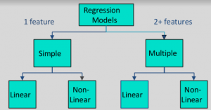

In [statistical modeling](https://en.wikipedia.org/wiki/Statistical_model), regression analysis is a set of statistical processes for [estimating](https://en.wikipedia.org/wiki/Estimation_theory) the relationships among variables. It includes many techniques for modeling and analyzing several variables, when the focus is on the relationship between a [dependent variable](https://en.wikipedia.org/wiki/Dependent_variable) and one or more [independent variables](https://en.wikipedia.org/wiki/Independent_variable) or predictors). More specifically, regression analysis helps one understand how the typical value of the dependent variable or criterion variable changes when any one of the independent variables is varied, while the other independent variables are held fixed.

Regression analysis is widely used for [prediction](https://en.wikipedia.org/wiki/Prediction) and [forecasting](https://en.wikipedia.org/wiki/Forecasting), where its use has substantial overlap with the field of [machine learning](https://en.wikipedia.org/wiki/Machine_learning). Regression analysis is also used to understand which among the independent variables are related to the dependent variable, and to explore the forms of these relationships. In restricted circumstances, regression analysis can be used to infer [causal relationships](https://en.wikipedia.org/wiki/Causality) between the independent and dependent variables. However, this can lead to illusions or false relationships, so caution is advisable.

Regression models involve the following parameters and variables:

* The unknown parameters, denoted as {\displaystyle \beta }*B*, which may represent a [scalar](https://en.wikipedia.org/wiki/Scalar_(physics)) or a [vector](https://en.wikipedia.org/wiki/Euclidean_vector).
* The independent variables, {\displaystyle X}.
* The dependent variable, {\displaystyle Y}.

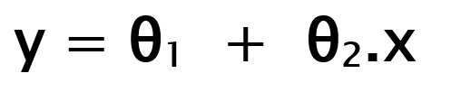

While training the model we are given:

**x:** input training data.  
**y:** labels to data (supervised learning)

When training the model – it fits the best line to predict the value of y for a given value of x. The model gets the best regression fit line by finding the best θ1 and θ2 values.  
**θ1:** intercept  
**θ2:** coefficient of x

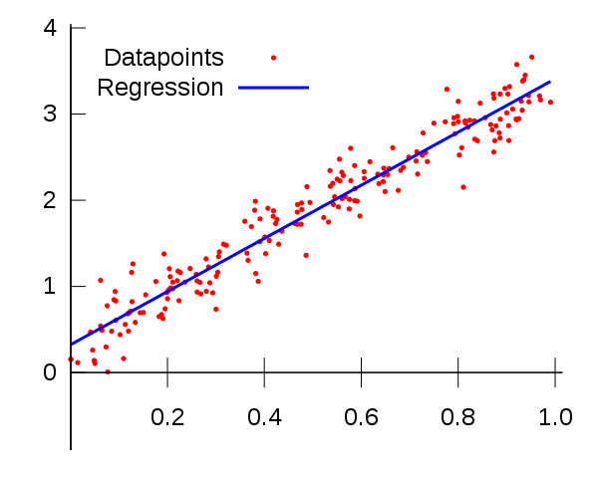

## **FEASIBILITY STUDY**

During system analysis, a feasibility study of the proposed system was carried out to see whether it was beneficial to the organization. The main aim of the feasibility study is to determine whether it would be financially and technically feasible to develop the product. While evaluating the existing system, many advantages and disadvantages raised. Analyzing the problem thoroughly forms the vital part of the system buddy. Problematic areas are identified and information is collected. The benefits of this application are users can easily interact and get the services without much complexity. It helps to make it possible that more users can interact with the application at a time. Feasibility study is to determine whether the proposed system is technically, economically and behaviorally feasible in all respects.

The main aim of feasibility study is to evaluate alternative application and propose the most feasible and desirable application development. If there is no loss for the organization, then the proposed system is considered financially feasible. A feasibility study is carried out to select the best system that meets performance requirements. The feasibility study activity involves the analysis of the problem and collection of all relevant information relating to the product such as the different data items which would be input to the system, the processing required to be carried out on these data, the output data required to be produced by the system as well as various constraints on the behavior of the system. In this scenario, problems are identified. Essential data are being gathered for the existing problems. It is necessary that this analysis familiarizes the designer with objectives, activities, and the function of the organization in which the system is to be implemented. The feasibility study was divided into four: - Technical, Economical, Operational and Behavioral. It is summarized below: -

* + - Technical Feasibility
    - Economical Feasibility
    - Operational Feasibility
    - Behavioral Feasibility

## **Technical Feasibility**

According to feasibility analysis procedure the technical feasibility of the system is analyzed and the technical requirements such as software facilities, procedure, inputs, are identified. While considering the problems of existing system, it is sufficient to implement the new system. The proposed system can be implemented to solve issues in the existing system. It includes the evaluation of and how it meets the proposed system. This system use Python as front end technology and SQL Server as back end technology.

## **Economical Feasibility**

Economic analysis is most frequent used for evaluating of the effectiveness of the candidate system. More commonly known as cost/benefit analysis the procedure is to determine the benefit and saving that are expected from a candidate system and compare them with the existing system. Except for the initial capital amount and the amount after each financial year, no other huge amount is needed. The expenses can be handles by any participants. So, the system is economically feasible.

This feasibility involves some questions such as whether the firm can afford to build the system, whether its benefits should substantially exceed its costs, and whether the project has higher priority and profits than other projects that might use the same re- sources. Here there is no problem. This firm has fully equipped hard ware, and fully fledged software, so no need to spend money on these issues. And as the client and the developer are one, there is no further problem in economic issues.

## **Operational Feasibility**

Methods of processing and presentation are all according to the needs of clients since they can meet all user requirements here. The proposed system will not cause any problem under any circumstances and will work according to the specifications mentioned. Hence the proposed system is operationally feasible. People are inherently resistant to change and computer has been known to facilitate changes. The system operation is the longest phase in the development life cycle of a system. So, Operational Feasibility should be given much importance. This system has a user-friendly interface. Thus it is easy to handle.

## **Behavioral Feasibility**

In today’s world, computer is an inevitable entity. As per the definition of behavior design, many valid points are recognized in this study. This system behavior changes according to different environment. In order to ensure proper authentication and authorization and security of sensitive data of the admin or users, login facilities are provided. These are the main feasibility studies tested in this application.

# 

# 

# CHAPTER 3

# SYSTEM ANALYSIS AND DESIGN

* 1. **SOFTWARE REQUIRMENT AND SPECIFICATION**

**3.1.1 Project Scope**

System Requirements Specification is a structured collection of information that incorporates the requirements of a system. This gives an idea about the system specifications required to develop and install the project “INVESTAVENUE ”. The System Requirements Specification is a technical specification of requirements for the software product. The goal of software requirements definition is to completely and consistently specify the technical requirements for the software product in a concise and unambiguous manner.

The System Requirements Specification is based on the System Definition. The requirement specifications are primarily concerned with functional and performance aspect of a software product and emphasis are placed on specifying product characteristics implying how the product will provide those characteristics. One of the most difficult tasks is selecting software, once the system requirement is find out then we have to determine whether a particular software package fits for those system requirements. This selection summarizes the application requirement.

## **Product Perspective**

The system will used to manage the wealth details of the user. Here we collect ll the detail sfrom the user itself. By using the collected data the system will predict the useful wealth management ways for the use. The successful prediction will be help the user to save their wealth in a good manner. The proposed system deals with a machine learning model to predict financial advises which eventually depends on many factors and taking into account the nonlinearities and discontinuities of the factors which are considered to impact financial advises.

## **Product Features**

This application deals with the prediction for financial management by using the data collected from the customer in the form of his/her asset , expense ,liabilities. Web scrapping is used to extract data from the web for the prediction. It uses Angular 4 as the front-end and oracle11 as the back-end. It used Machine Learning model regression to predict the advices.

## **User Classes and Characteristics**

There are two type of users in the application. The registered user and the guest user. The system itself control the application. There is no any role of administrator in the application. By using the prediction the application provide advices to the customer. For a guest user there is no any specified role. They have only the permission to view the activities and also they can register to the system to continue as a registered user.

## **Operating Environment**

Windows Operating System with a minimum hard disk space and RAM is used for the development of the system.

## **FUNCTIONAL REQUIREMENTS**

**3.2.1 REQUIREMENTS IN SCOPE**

The Application should have the following features:

* It should give a brief information about InvestoAvenue and their business history
* It should provide an option in the homepage for clients to register and login
* It should allow different categories of clients to register and avail the services. Some categories of clients that can be considered are:

Individuals

Medium Scale Industries

Corporates

* It should allow a client to add his/her (in case of an individual) or his/her firm’s (in case of Medium Scale industries or Corporates) basic details during registration
* It should allow a client to add the following details mandatorily upon attempting to seek financial/investment guidance:
* What are the things you want to save and invest for:

Home

Car

Education

Medical Emergencies

Periods of Unemployment

Periods of Low productivity

Periods of recession

Untoward incidents

* What is your Net worth statement? This will include a list of all assets (along with their value) like:

Cash

Checking Accounts

Savings

Cash Value of life insurance

Retirement Accounts

Properties

* It will also include a list of all liabilities (along with their amount) like:

Mortgage Balance

Credit cards

Bank Loans

Factory Loans

* It should incorporate an analytical algorithm that would suggest the clients a list of the most appropriate investment options based on the various parameters/information provided by the clients
* It should allow payment of the specified charges for the services availed o It should allow clients to rate the application and provide a feedback on its performance
* It should pick the best positive reviews written by the registered clients and display them on the homepage

**Hardware requirements**

Processor : Intel Pentium or More

RAM : 128 MB or more

Cache : 512 KB

Hard Disk : 16 GB Hard Disk recommended

Drive : CD/DVD

Keyboard : Logitech Standard 101 Keys

Mouse : Logitech

Monitor : LCD Color Monitor

Table 3.1 : Hardware requirements

**Software Specification**

Operating System : Windows 10

Front End : Anguular4

Back End : Oracle 11

Web Browser : Google Chrome

Table 3.2 :Software requirement

## **NON-FUNCTIONAL REQUIREMENTS**

**Security**

Users should be able to login by providing a unique user id and password which will fulfil the security requirements

**Multi language Support**

Should support only English language.

**Performance**

Application should be light and responsive

**Scalability**The Application must support multiple users without performance degradation.

**Availability / reliability**

The probability of failure should be as less as possible.

## **DATA FLOW DIAGRAM**

A DFD is a graphical representation of the flow of data through an information system, modeling its process aspects. Often they are preliminary step used to create an overview of the system which can later be elaborated. DFDs can also be used for the visualization of data processing (structured design). So it is the starting point of design phase that functionally decomposes the requirements specifications down to the lowest level of detail. A DFD consists of a series of bubbles joined by lines.

DFD is a way of representing a flow of a data of a [process](https://en.wikipedia.org/wiki/Process) or a system (usually an [information system](https://en.wikipedia.org/wiki/Information_system)). The DFD also provides information about the outputs and inputs of each entity and the process itself. A data-flow diagram has no control flow, there are no decision rules and no loops. Specific operations based on the data can be represented by a [flowchart](https://en.wikipedia.org/wiki/Flowchart).

There are several notations for displaying data-flow diagrams. For each data flow, at least one of the endpoints (source and / or destination) must exist in a process. The refined representation of a process can be done in another data-flow diagram, which subdivides this process into sub-processes.

**DFD Symbols**

1) -------------> Source or destination

2) ------------> Process

3) ------------> Data flow

4) ------------> Data store

## **Level 0 DFD**

## 

## Fig 3.1 showing investoavenue

## **Level 1 DFD**

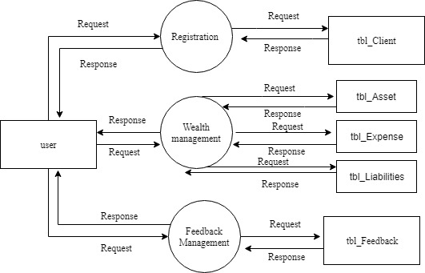

Fig 3.2 showing investoavenue

## **Level 2 DFD**

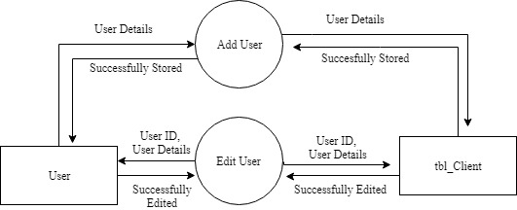

Fig 3.3 showing registration management

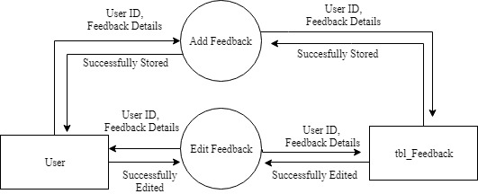

Fig 3.4 showing feedback management

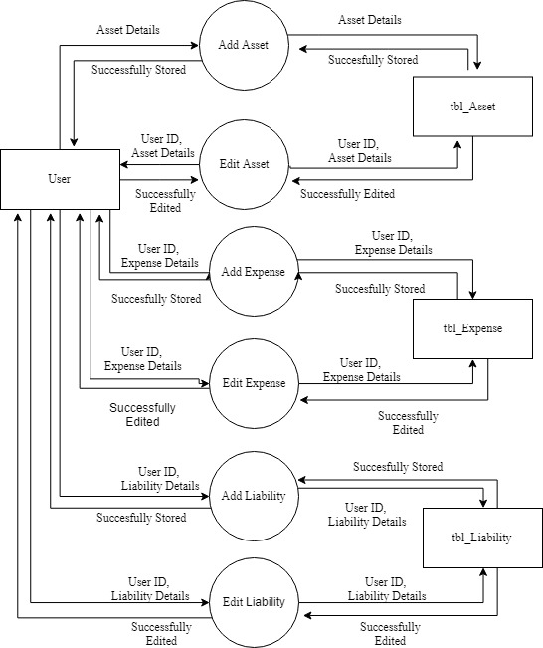

Fig 3.5 showing wealth management

## **3.5 UML DIAGRAM**

UML is a way of visualizing a software program using a collection of diagrams. The notation has evolved from the work of Grady Booch, James Rumbaugh, Ivar JAcobson and the Rational Software Corporation to be used for object-oriented design, but it has since been extended to cover a wider variety of software engineering projects. Today, UML is accepted by the Object Management Group(OMG) as the standard for modelling software development.

UML stands for Unified Modeling Language. UML 2.0 helps extend the original UML specification to cover a wider portion of software development efforts including agile practices. Improved integration between structural models like class diagrams and behavior models like activity diagrams. The original UML specified nine diagrams; UML 2.x brings that number up to 13. The four new diagrams are called: communication diagram, composite diagram, interaction overview diagram and timing diagram. It also renamed state chart diagrams to state machine diagrams, also known as state diagrams.

## **Types of UML diagrams**

The current UML standards call for 13 different types of diagrams: class, activity, object, use case, sequence, package, state, component, communication, composite structure, interaction overview, timing and deployment. These diagrams are organized into two distinct groups: structural diagrams and behavioral or interaction diagrams.

## Structural UML diagrams

* + - Class diagram
    - Package diagram
    - Object diagram
    - Component diagram
    - Composite structure diagram
    - Deployment diagram

## **Behavioral UML diagrams**

* + - Activity Diagram
    - Sequence diagram
    - Use case diagram
    - State diagram
    - Communication diagram
    - Interaction overview diagram
    - Timing diagram

## **3.5.1 Use case Diagram**

To model a system, the most important aspect is capture the dynamic behavior. To modify a bit in details, dynamic behavior of the system when it is running or operating. So only behavior is not sufficient to model a system rather dynamic behavior is more important than static behavior. In UML there are five diagrams available to model dynamic nature and use case diagram is one of them. Now as we have to discuss that the use case diagram is dynamic in nature there should be some internal or external factors for making the interaction. These internal and external agents are known as actors. So use case diagram consists of actors, use case and their relationships. The diagram is used to model the system of an application. A single use case diagram captures a particular functionality of a system.

Use case Diagram objects:

* Actor
* Use case
* System
* Package

## **Actor**

A use case defines the interactions between external actors and the system under consideration to accomplish a goal. Actors must be able to make decisions, but need not be human: An actor might be a person, a company or organization, a computer program, or a computer system—hardware, software, or both. Actors are always [stakeholders](https://en.wikipedia.org/wiki/Project_stakeholder), but not all stakeholders are actors, since they never interact directly with the system, even though they have the right to care how the system behaves. For example, the owners of the system, the company's board of directors, and regulatory bodies such as the Internal Revenue Service and the Department of Insurance could all be stakeholders but are unlikely to be actors.



Figure 3.6: Actor

A use case represents a function or an action within the system. Its drawn as an oval and named with the function.

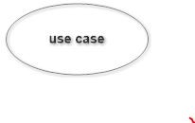 Figure 3.7: Use case

## **System**

System is used to define the scope of the use case and drawn as a rectangle. This is an optional element but useful when your visualizing large systems

## **Package**

Package is another optional element that is extremely useful in complex diagrams. Similar to use class diagrams, packages are used to group together use cases.

## **Sequence Diagram**

UML sequence diagrams are used to represent or model the flow of messages, events and actions between the objects or components of a system. Time is represented in the vertical direction showing the sequence of interaction of the header elements. Sequence diagrams are used primarily to design, document and validate the architecture, interfaces and logic of the system by describing the sequence of actions that need to be performed to complete a task. UML sequence diagrams are useful design tools because they provide a dynamic view of the system behavior which can be difficult to extract from static diagrams or specifications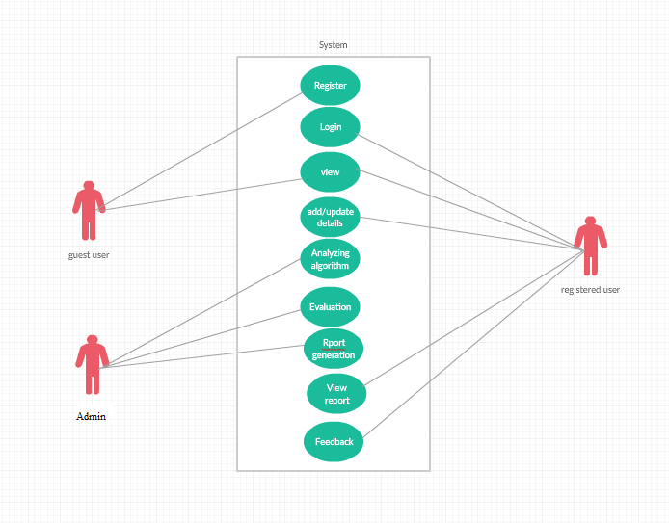

Fig 3.8 Use case diagram

Although UML sequence diagrams are typically used to describe object-oriented software systems, they are also extremely useful as system engineering tools to design system architectures in business process, as message sequence charts and call flows for telecoms or wireless system design, and for protocol stack design and analysis.

A sequence diagram is an interaction diagram that shows how objects operate with one another and in what order. It is a construct of a message sequence chart. A sequence diagram shows object interactions arranged in time sequence. It depicts the objects and classes involved in the scenario and the sequence of messages exchanged between the objects needed to carry out the functionality of the scenario. Sequence Diagrams are typically associated with use case realizations in the logical View of the system under development. Sequence diagrams are sometimes called event diagrams or event scenarios.

A sequence diagram shows, as parallel vertical lines (lifelines), different processes or objects that live simultaneously, and, as horizontal arrows, the messages exchanged between them, in the order in which they occur. This allows the specification of simple runtime scenarios in a graphical manner.

* 1. **SYSTEM DESIGN**
     1. **Input Design**

The input design is the link that lays the information system to the world of users. In input design user defined inputs are converted into computer-based format. Input design involves determining the record media, method of input, speed of capture and entry to the system. The data is fed into the system using simple interactive forms. Input design consists of developing specification and procedures for data preparation, steps necessary to put transaction data in a form that is unable for computer processing.

The data is validated wherever it requires in the project. This ensures only correct data is entered to the system. TKinter is the module used for designing the input forms. All the input data are validated in the order and if any data violates any condition the use is warned by a message and asks to re-enter data. If the data satisfies all the conditions, then it is transferred to the appropriate tables in the database. This project uses text boxes and drop down to accept user input. If user enters wrong format, then it shows a message to the user. User is never lift in confusion as to what is happening. Instead appropriate error messages and acknowledgements are displayed to the user.

**3.6.2 Output Design**

A quality output is one, which meets the requirement of the end user and presents the information clearly. In any system results of processing are communicated to the user and to the other systems through outputs. In the output design it is determined how the information is to be displayed for immediate need. It is the most important and direct source information to the user. Efficient and intelligent output design improves the system’s relationship and helps user decision making.

It generally refers to the results and the information that are generated by the system. Effective, descriptive and useful design will improve the relationship with the user and the system because it is the direct source of information to the user. The objective of the output design is to convey the information of all the past activities, required status and to emphasize important events. Outputs from the computers are providing primarily to communicate the results of processing to the user. They also used to provide a permanent copy of these results for later consultation. The major outputs are system flow diagrams and data flow diagram.

The outputs have been designed as per the needs for the management. The suggestions of the users are also take in to consideration while designing the layouts and the fields that are to include in the prediction of stocks. Considering the future use of the output required and depending on the nature, the output is either displayed on the monitor for immediate need.

* + 1. **Database Design**

Database is a design to manage large bodies of information. The management of data involves both the definition of structures for the storage information. In addition, the database system must provide for the safety of the information solved, despite system crashes or due to attempts at unauthorized access. For developing an efficient database, we have to fulfil certain condition such as controlled redundancy

* + - * Defining the data
      * Inputting the data
      * Locating the data
      * Accessing the data
      * Communicating the data
      * Revising the data

**OBJECTIVES OF DATABASE**

In the database design, several objectives are considered such as

* + - * Control of data Integrity
      * Ease of use
      * Control of redundancy
      * Control of security
      * Data independence (Logical and physical)
      * Data storage protection (Record level and Table level)
      * System performance
      * System functions
      * System compatibility

For achieving the above mentioned criteria’s we have to make use various features that are available with the RDBMS by enforcing integrity constraints, we can ensure data integrity and reduce data inconsistency to a great extent. Recovery from failures can overcome using backup facilities. By using table level as well as row level locking facilities, we can avoid concurrent access normalize. Another important features of RDBMS are the logical and physical data independence. In addition to security mechanism provided by RDBMS, we have provided system password to near system.

**NORMALIZATION**

Normalization is the term obtained from the Latin word NORMA which means that square used by the carpenter. Normalization is the process of simplifying the relationship between data elements in a record, through normalization a collection of data a record structure is replaced by successive record structures that are simpler and can be managed efficiently. While designing the database, we have to implement the concept of normalization to avoid data redundancy in the database. Normalization is carried out for four reasons.

* + - * To structure the data so that any pertinent relationship between entities can be represented.
      * To permit simple retrieval of data in response to query and reports required.
      * To simplify data maintenance procedures such as insertion, deletion and updating.
      * To reduce the need to be structure or reorganize data with new application requirements arise.

The major normalization strategies are

* + - * First Normal Form
      * Second Normal Form
      * Third Normal Form
      * Boyce/Codd Normal Form(BCNF)

**FIRST NORMAL FORM**

First Normal Form is achieved when all repeating groups in a record are removed, so that record is of fixed length. A repeating group, reoccurrence of a data item or group of data item within a record indicates another relation.

**SECOND NORMAL FORM**

Second Normal Form is achieved when a record is in first normal form and each item in the record is functionally depend on the primary key for identification. In other words, analyst seeks functional dependency. A data item is functionally dependent of its value is uniquely associated with a specific data item is functionally dependent of its value is uniquely associated with a specific item. To achieve second normal form every column in a table that is not dependent on the primary key of the record should be removed and used to form a separate relation.

**THIRD NORMAL FORM**

Third Normal Form is achieved when all transitive dependencies are removed from a record. That is, if A is functionally dependent on B and B is functionally dependent on C, then A is functionally dependent on C.

**BOYCE/CODD NORMAL FORM(BCNF)**

BCNF is often used to distinguish the new 3NF from the old. An attribute possible composite is called as determinant. If other attributes are fully functionally determined this attribute (or on which some other attribute is fully functionally dependent on this attribute). A table is in BCNF, if every determinant is a candidate key. To achieve a table is in BCNF, remove fields which are fully functionally dependent on a determinant, which is not act as a candidate key.

|  |  |  |
| --- | --- | --- |
| **Field** | **Data Type** | **Constraints** |
| userId | varchar2(30) | PRIMARY KEY |
| Name | varchar2(30) | not null |
| typeOfClient | varchar2(30) | not null |
| password | varchar2(30) | not null |
| contactNo | number(10) | not null |
| email | varchar2(40) | not null |
| cdate | date | not null |
| detail | varchar2(1) | not null |

Table 3.3 :tblClient

|  |  |  |
| --- | --- | --- |
| **Field** | **Data Type** | **Constraint** |
| userId | varchar2(30) | FOREIGN KEY |
| ExpensesId | number(5) | PRIMARY KEY |
| income | number | Not null |
| expenditure | Number | not null |

Table 3.4 : tblExpenses

|  |  |  |
| --- | --- | --- |
| **Field** | **Data Type** | **Constraint** |
| userId | varchar2(30) | FOREIGN KEY |
| LiabilityId | number(5) | PRIMARY KEY |
| mortageBalance | number | not null |
| creditCardLimit | number | not null |
| bankLoan | number | not null |
| emis | number | not null |

Table 3.5 :tblLiabilities

|  |  |  |
| --- | --- | --- |
| **Field** | **Data Type** | **Constraint** |
| userId | varchar2(30) | FOREIGN KEY |
| interestId | number(5) | PRIMARY KEY |
| interest | varchar2(30) | not null |
| timeFrame | number | not null |
| amount | number | not null |

Table 3.6 :tblInterests

|  |  |  |
| --- | --- | --- |
| **Field** | **Data Type** | **Constraint** |
| userId | varchar2(30) | FOREIGN KEY |
| AssetsId | number(5) | PRIMARY KEY |
| cash | number | not null |
| checkingAccounts | number | not null |
| saving | number | not null |
| cashOfLifeInsurance | number | not null |
| retirement | number | not null |
| properties | number | not null |
| noOfVehicles | number | not null |
| medicalInsurance | varchar2(10) | not null |

Table 3.7:tblAssets

|  |  |  |
| --- | --- | --- |
| **Field** | **Data Type** | **Constraint** |
| userId | varchar2(30) | FOREIGN KEY |
| feedbackId | number(5) | PRIMARY KEY |
| star | number | not null |
| feedbackMessage | varchar2(50) | not null |

Table 3.8:tblFeedback

|  |  |  |
| --- | --- | --- |
| **Field** | **Data Type** | **Constraint** |
| UserId | varchar2(30) | FOREIGN KEY |
| corporateId | number(5) | PRIMARY KEY |
| Account | number | not null |
| Cash | number | not null |
| debts | number | not null |
| property | number | not null |
| netProfit | number | not null |

Table 3.9:tblCorporate

* 1. **TOOLS AND PLATFORMS**

**3.7.1 ANGULAR**

UI designing is one of the most crucial parts of any application. UI is where the user interacts with any application, hence it has to be designed in a user-friendly manner. Many frameworks have come into existence for the same. Angular is one such very powerful framework for building client applications using any scripting language such as JS or TypeScript. The most preferred scripting language for Angular is TypeScript which can again be compiled to JavaScript. Any UI designer would appreciate Angular if he already knows any traditional approaches as this framework helps us in designing application with better performance and maintainability for both mobiles and desktops.

AngularJS is based on the model view controller, whereas Angular 2 is based on the components structure. Angular 4 works on the same structure as Angular2 but is faster when compared to Angular2.

Angular4 uses TypeScript 2.2 version whereas Angular 2 uses TypeScript version 1.8. This brings a lot of difference in the performance.

To install Angular 4, the Angular team came up with Angular CLI which eases the installation.

The Angular 4 app folder has the following **folder structure** −

* **e2e** − end to end test folder. Mainly e2e is used for integration testing and helps ensure the application works fine.
* **node_modules** − The npm package installed is node_modules. You can open the folder and see the packages available.
* **src** − This folder is where we will work on the project using Angular 4.

The Angular 4 app folder has the following **file structure** −

* **.angular-cli.json** − It basically holds the project name, version of cli, etc.
* **.editorconfig** − This is the config file for the editor.
* **.gitignore** − A .gitignore file should be committed into the repository, in order to share the ignore rules with any other users that clone the repository.
* **karma.conf.js** − This is used for unit testing via the protractor. All the information required for the project is provided in karma.conf.js file.
* **package.json** − The package.json file tells which libraries will be installed into node_modules when you run npm install.

The src folder is the main folder, which internally has a different file structure.

**app**-It contains the files described below. These files are installed by angular-cli by default.

* app.module.ts − If you open the file, you will see that the code has reference to different libraries, which are imported. Angular-cli has used these default libraries for the import – angular/core, platform-browser. The names itself explain the usage of the libraries.

They are imported and saved into variables such as **declarations, imports, providers**, and **bootstrap**.

**declarations** − In declarations, the reference to the components is stored. The Appcomponent is the default component that is created whenever a new project is initiated. We will learn about creating new components in a different section.

**imports** − This will have the modules imported as shown above. At present, BrowserModule is part of the imports which is imported from @angular/platform-browser.

**providers** − This will have reference to the services created. The service will be discussed in a subsequent chapter.

**bootstrap** − This has reference to the default component created, i.e., AppComponent.

* **app.component.css** − You can write your css structure over here. Right now, we have added the background color to the div as shown below.
* **app.component.html** − The html code will be available in this file.

This is the default html code currently available with the project creation.

* **app.component.spec.ts** − These are automatically generated files which contain unit tests for source component.
* **app.component.ts** − The class for the component is defined over here. You can do the processing of the html structure in the .ts file. The processing will include activities such as connecting to the database, interacting with other components, routing, services, etc.

**Angular and TypeScript**

Angular is one of the most powerful client-side U.I. framework which can be used to develop **complex**, **customizable**, **modern**, **responsive** and **userfriendly** web applications. Some such applications are PayPal, Netflix, Weather etc.Angular is a single framework which addresses concernsof bothmobileanddesktop application.The Angular framework has chosen a **new statically-typed**, **client-side scripting** language called TypeScript, which beautifully works around most if not all such pitfalls of JavaScript. The Angular team recommends the usage of TypeScript for Angular applications. Hence, to start building Angular applications, we would need to learn to write simple TypeScriptcode first and then look at the Angular application design.

**Pitfalls of JavaScript**

JavaScript is the language used for client side scripting. We can do client side validations, DOM manipulation, Ajax calls etc using JavaScript. We can also use JavaScript frameworks for writing complex business logic which runs on the client side.

As the complexity of the JavaScript code increases, it gradually becomes difficult in coding and maintaining. This is because of the following pitfalls of JavaScript language.

**Dynamic Typing**: Dynamic typing means deciding the data type of the variable dynamically at runtime which results in recompilation every time the code is executed.

**Interpreted Language**: Interpreted Language is a language in which the code instructions are executed directly without prior compilation to machine-language instructions hence we will not get to know the errors until the code is executed.

**Minimal Object Oriented support**: JS supports minimal Object Oriented concepts like classes, encapsulation, inheritance which helps in readability and reusability of the code.

**Minimal IDE support**: Integrated development environment (IDE) is a software application that provides all necessary options like code refactoring, intellisense support, Debugging support to software programmers for software development which is least supported in JS.

Albeit all these shortcomings, we are still dependent on JS as it is the most common scripting language for browsers. But as programmers, we might be in luck.

The solution can be to choose a language which is rich in features and the code can be converted to JavaScript for browsers. This process of converting code written in one language into another language is generally called Transpilation.

TypeScript is one such language whose code can be transpiled to JavaScript. This conversion is required because browser cannot understand TypeScript code.

**What is TypeScript**

TypeScript is a typed superset of JavaScript that transpiles to JavaScript.

* TypeScript makes the development of JavaScript nearer to a more traditional object oriented experience.
* TypeScript is based on [ECMAScript](http://www.ecma-international.org/) 7 proposals.
* Apart from the EcmaScript specification, TypeScript has its own features as well.
* Any valid JavaScript is TypeScript.

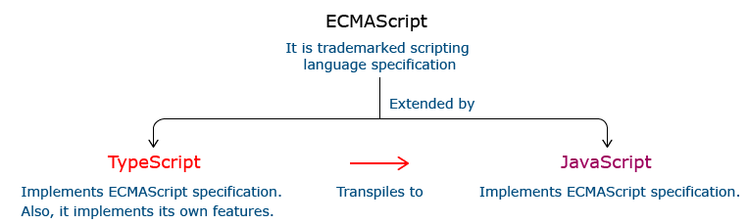

**Relationship Between TypeScript and JavaScript**

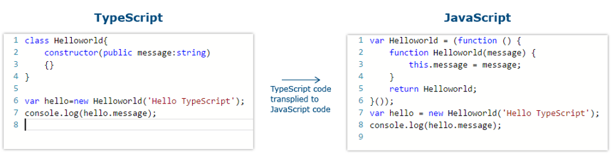

**I**n the code given above, the TypeScript class HelloWorld is converted to a self invoking function in JavaScript when transpiled.

**Features Of TypeScript**

**Static Typing**: It adds static typing to JavaScript, due to which the readability of the code improves and also helps in finding more early compilation errors than the runtime errors.

**Modules support:**TypeScript provides an option to create modules so that we can modularize the code for easy maintenance. Modules also help in making the application scalable.

**Object Oriented Programming:**TypeScript supports object oriented programming features such as classes, encapsulation, interface, inheritance and so on which help in creating highly structured and reusable code.

**Open Source:**TypeScript is open source. The source code of TypeScript can be downloaded from github.

**Cross Platform: It works across platforms.**

**Tooling Support:**TypeScript works extremely well with Sublime Text, Eclipse, and almost all major IDEs as compared to JavaScript

**3.7.2 VISUAL STUDIO CODE IDE**

Visual Studio Code is a source-code editor developed by Microsoft for Windows, Linux and macOS. It includes support for debugging, embedded Git control and GitHub, syntax highlighting, intelligent code completion, snippets, and code refactoring. It is highly customizable, allowing users to change the theme, keyboard shortcuts, preferences, and install extensions that add additional functionality. The source code is free and open source and released under the permissive MIT License. The compiled binaries are freeware and free for private or commercial use.

Visual Studio Code is based on Electron, a framework which is used to deploy Node.js applications for the desktop running on the Blink layout engine. Although it uses the Electron framework, the software does not use Atom and instead employs the same editor component (codenamed "Monaco") used in Azure DevOps (formerly called Visual Studio Online and Visual Studio Team Services).

Typescript code can be written using several IDEs such as - Eclipse IDE, NetBeans IDE, Visual Studio Code IDE etc. We are prefer using Visual Studio Code IDE as it is a lightweight cross-platform editor which comes with built-in TypeScript support.

Typescript code is written in Visual Studio Code IDE in the following way:

**Step 1:**Create a folder on your desktop. This folder will be used as a work-space for Visual Studio Code. Let us name it **TypeScript_WorkSpace.**

**Step 2:** Create a folder and name it as **Demo**, inside the previously created folder. This folder will be used as a project folder.

**Step 3:**Launch Visual Studio Code IDE. Once launched, close the welcome page. We should get a screen similar to the one shown below.

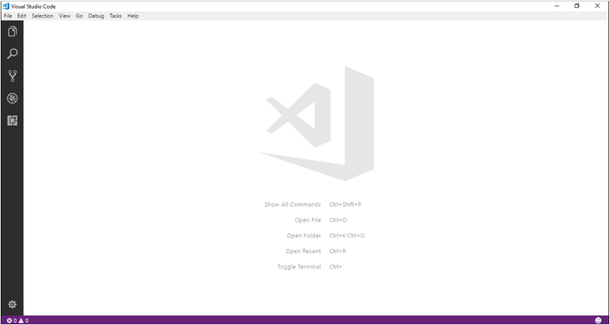

**Step 4:**Next step is to select a workspace. From the **File** menu, select **OpenFolder,** browse for the TypeScript_Demos folder and select it.

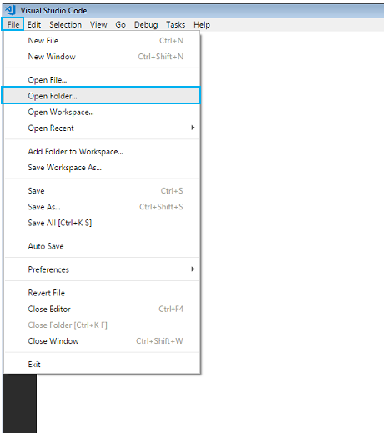

**Step 5:**The IDE will restart and the folder will be selected as work-space. We will also have the **TS_Demo** project folder as shown below.

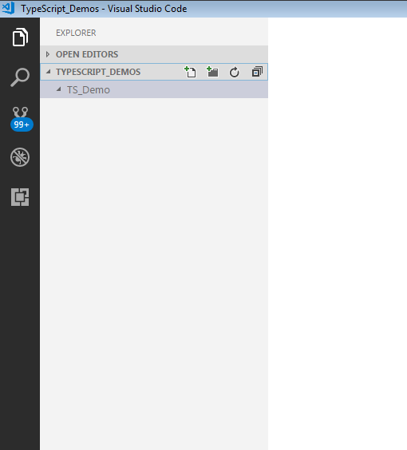

**Step 6:** Let us create a typescript file. Create a file named **firstApp.ts** in the project folder.

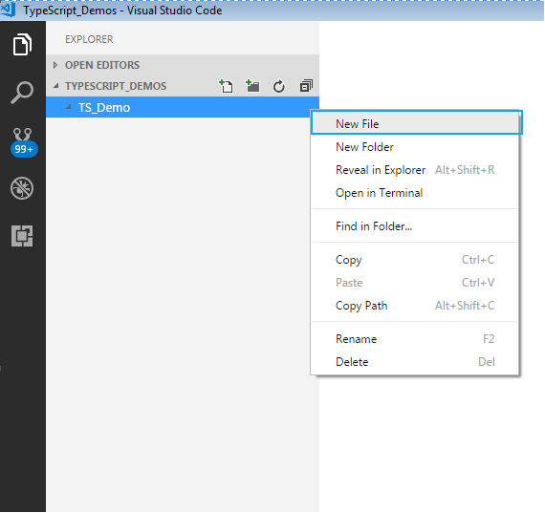

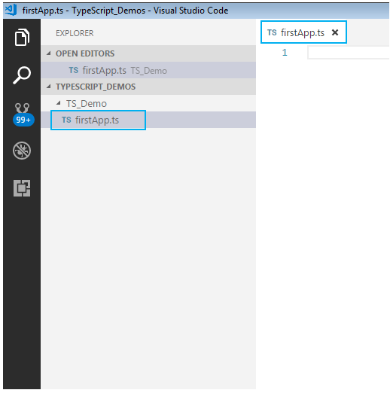

To start with the first application in TypeScript, in already created firstApp.ts file, give a console.log

statement and save it.

Here is how to do this:

**Step 7:** We shall print a welcome message when we run the above file. To do so, let us code as shown

**console.log("Hello! Welcome to TypeScript");**

**Step 8:**

To execute the code, we will have to navigate to the project folder. For this, we will use windows command prompt through VSCode. Open the command prompt by following step:

* Navigate to View tab in VSCode.
* Select Integrated Terminal.

Alternatively, you can use the shortcut, **ctrl+`**, to open the command prompt. We will get the command prompt as shown below.

From the command prompt navigate to the folder in which the ts file resides and **transpile**the **.ts** file using the **tsc**command as follows:

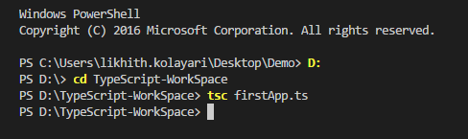

**Step 9:** Run the transpiled **.js** file using  **node**  command . On execution of the code, the output is

displayed on the console as shown.

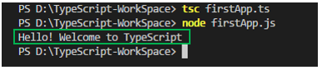

**3.7.3 ORACLE**

The Oracle Server is a relational database management system that provides an open, comprehensive, and integrated approach to information management. An Oracle Server consists of an Oracle database and an Oracle instance. The following sections describe the relationship between the database and the instance.

### Structured Query Language (SQL)

SQL (pronounced SEQUEL) is the programming language that defines and manipulates the database. SQL databases are relational databases; this means simply that data is stored in a set of simple relations. A database can have one or more tables. And each table has columns and rows. A table that has an employee database, for example, might have a column called employee number and each row in that column would be an employee's employee number.

You can define and manipulate data in a table with SQL commands. You use data definition language (DDL) commands to set up the data. DDL commands include commands to creating and altering databases and tables.

You can update, delete, or retrieve data in a table with data manipulation commands (DML). DML commands include commands to alter and fetch dat. The most common SQL command is the SELECT command, which allows you to retrieve data from the database.

In addition to SQL commands, the Oracle Server has a procedural language called PL/SQL. PL/SQL enables the programmer to program SQL statements. It allows you to control the flow of a SQL program, to use variables, and to write error-handling procedures.

### **Database Structure**

An Oracle database has both a physical and a logical structure. Because the physical and logical server structure are separate, the physical storage of data can be managed without affecting the access to logical storage structures.

**Physical Database Structure**An Oracle database's physical structure is determined by the operating system files that constitute the database. Each Oracle database is made of three types of files: one or more datafiles, two or more redo log files, and one or more control files. The files of an Oracle database provide the actual physical storage for database information.

**Logical Database Structure** An Oracle database's logical structure is determined by

* one or more tablespaces. (A tablespace is a logical area of storage explained later in this chapter.)
* the database's schema objects. A *schema* is a collection of objects. *Schema objects* are the logical structures that directly refer to the database's data. Schema objects include such structures as tables, views, sequences, stored procedures, synonyms, indexes, clusters, and database links.

The logical storage structures, including tablespaces, segments, and extents, dictate how the physical space of a database is used. The schema objects and the relationships among them form the relational design of a database.

### **An Oracle Instance**

Every time a database is started, a system global area (SGA) is allocated and Oracle background processes are started. The system global area is a an area of memory used for database information shared by the database users. The combination of the background processes and memory buffers is called an Oracle *instance.*

An Oracle instance has two types of processes: user processes and Oracle processes.

A user process executes the code of an application program (such as an Oracle Forms application) or an Oracle Tool (such as Server Manager).

Oracle processes are server processes that perform work for user processes and background processes that perform maintenance work for the Oracle Server.

**CHAPTER 4**

**SYSTEM TESTING**

Software testing is an integral part of to ensure software quality, some software organi- zations are reluctant to include testing in their software cycle, because they are afraid of the high cost associated with the software testing .There are several factors that at- tribute the cost of software testing. Creating and maintaining large number of test cases is a time consuming process. Furthermore, it requires skilled and experienced testers to develop great quality test cases.

Even with the wide availability of automation tools for testing, the degree of automa- tion mostly remains at the automated test script level and generally significant amount of human intervention is required in testing. In addition data collected, as testing is conducted provides a good indication of software quality as a while. The debugging process is the most unpredictable part of testing process. Testing begins at the module level and work towards the integration of entire computer based system. No testing is completed without verification and validation part.

The goal of verification and validation activities are to access and improve the qual- ity of work products generated during the development and modification of the soft- ware. Testing plays a vital role in determining the reliability and efficiency of the software and hence is very important stage in software development. Tests are to be conducted on the software to evaluate its performance under a number of conditions. Ideally, it should do so at the level of each module and also when all of them are inte- grated to form the completed system.

In the project ”E-Medication Reminder App And Healthcare system” the testing has been successfully handled with the modules. The test data was given to each and every module in all respect and got the desired output. Each module that has been tested is found working properly

**4.1 UNIT TESTING**

Here we test each module individually and integrated the overall system. Unit testing focuses verification efforts even in the smallest unit of software design in each module. This is known as ”module testing”. The modules of this project are tested separately. This testing is carried out in the programming style itself. In this testing each module is focused to work satisfactorily as regard to expected output from the module. There are some validation checks for the fields. Unit testing gives stress on the modules of the project independently of one another, to find errors. Different modules are tested against the specifications produced during the design of the modules. Unit testing is done to test the working of individual modules with test servers. Program unit is usu- ally small enough that the programmer who developed it can test it in a great detail. Unit testing focuses first on that the modules to locate errors. These error are verified and corrected and so that the unit perfectly fits to the project.

# INTEGRATION TESTING

Data can be lost across an interface, one module can have an adverse effect on the other sub-functions, when combined they may not perform the desired functions. Integrated testing is the systematic testing to uncover the errors within the interface. This testing is done with simple data and the developed system has run successfully with this simple data. The need for integrated system is to find the overall system performance. The Modules of this project are connected and tested. After splitting the programs into units, the units were tested together to see the defects between each module and function. It is testing to one or more modules or functions together with the intent of finding interface defects between the modules or functions. Testing completed at as part of unit or functional testing, integration testing can involve putting together of groups of modules and functions with the goal of completing and verifying meets the system requirements.

# SYSTEM TESTING

System testing focuses on testing the system as a whole. System Testing is a crucial step in Quality Management Process. In the Software Development Life Cycle, System Test ing is the first level where the System is tested as a whole. The System is tested to verify whether it meets the functional and technical requirements. The application/System is tested in an environment that closely resembles the production environment where the application will be finally deployed. The perquisites for System Testing are:-

* All the components should have been successfully Unit Tested.
* All the components should have been successfully integrated.

Testing should be completed in an environment closely resembling the production environment. When necessary iterations of System Testing are done in multiple environments.

# USER ACCEPTANCE TESTING

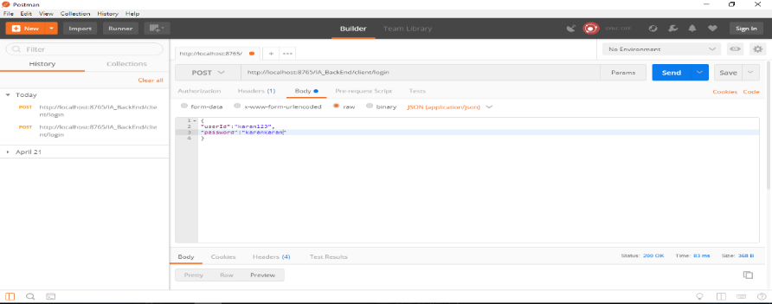The system was tested by a small client community to see if the program met the requirements defined the analysis stage. It was fond to be satisfactory. In this phase, the system is fully tested by the client community against the requirements defined in the analysis and design stages, corrections are made as required, and the production system is built. User acceptance of the system is key factor for success of the system.

Figure 4.1: Test case using POSTMAN

**CHAPTER 5**

**SYSTEM IMPLEMENTATION**

The implementation is one phase of software development. Implementation is that stage in the project where theoretical design is turned into working system. Implementation involves placing the complete and tested software system into actual work environment. Implementation is concerned with translating design specification with source code. The primary goal of implementation is to write the source code to its specification that can be achieved by making the source code clear and straight forward as possible. Implementation means the process of converting a new or revised system de- sign into operational one. The three types of implementation are : - implementation of a computerized system to replace a manual system, implementation of a new system to replace existing one and implementation of a modified system to replace an existing one.

The implementation is the final stage and it is an important phase. It involves the individual programming : system testing, user training , and the operational running of developed proposed system that constitute the application subsystem. The implementation phase of the software development is concerned with translating design specification in the source code. The user tests the developed system and the changes are according to the needs. Before implementation, several tests have been conducted to ensure no errors encountered during the operation. The implementation phase ends with an evaluation of the system after placing it into operation of time. The validity and proper functionality of all the modules of the developed application is assured during the process of implementation. Implementation is the process of assuring that the information system is operational and then allowing user to take over its operation for use and evaluation. Implementation is the stage in the project where the theoretical design is turned into a working system. The implementation phase constructs, installs and operated the new system. The most crucial stage in achieving a new successful system is that it works effectively and efficiently.

# CHAPTER 6 CONCLUSION

# The Project titled “INVESTOAVENUE ” is a web based application done using Angular as the front-end and Oracle11 as the back-end. The application will be used to help the client to manage their financial security. The system help the user to take better advices based on their Asset , liabilities , expense. By collecting all the data from the user the application will predict for the future and present management of their wealth in the form of education , retirement ,savings ,emergency cases etc. It will be a better application for the users to handling their asset and wealth in a proper way.

# CHAPTER7

# REFERENCES

* + - Bipin .C.Desai,An Introduction To Database System published by West.Publishing Company in 1990.
    - Somer Vilie, Software Engineering published by Pearson in March13,2010.
    - Sudarshan Silberschatz, Database System Concepts published by MCGraw- Hill Publication 2013.
    - <https://www.analyticsvidhya.com/blog/2018/10/predicting-stock-price-machine-learningnd-deep-learning-techniques-python/>
    - Henry F.Korth and Abraham Silberschatz,Database System Concepts published by MCGraw-Hill in 1986.

# CHAPTER 8

# APPENDIX

HomePage:

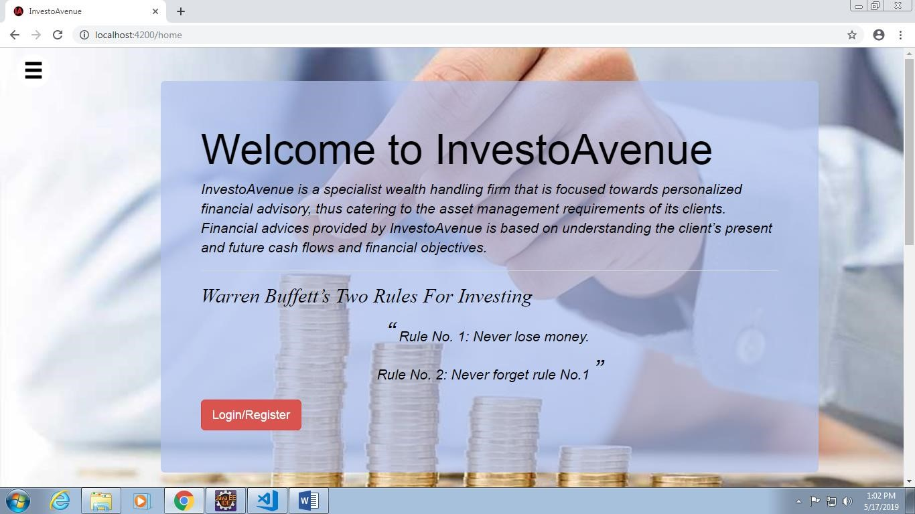

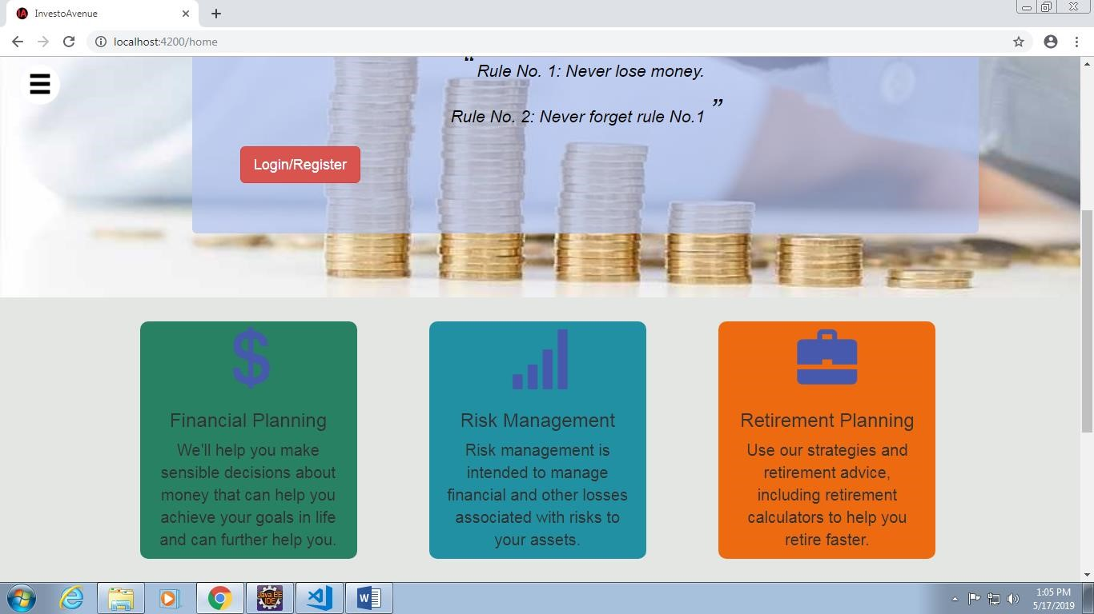

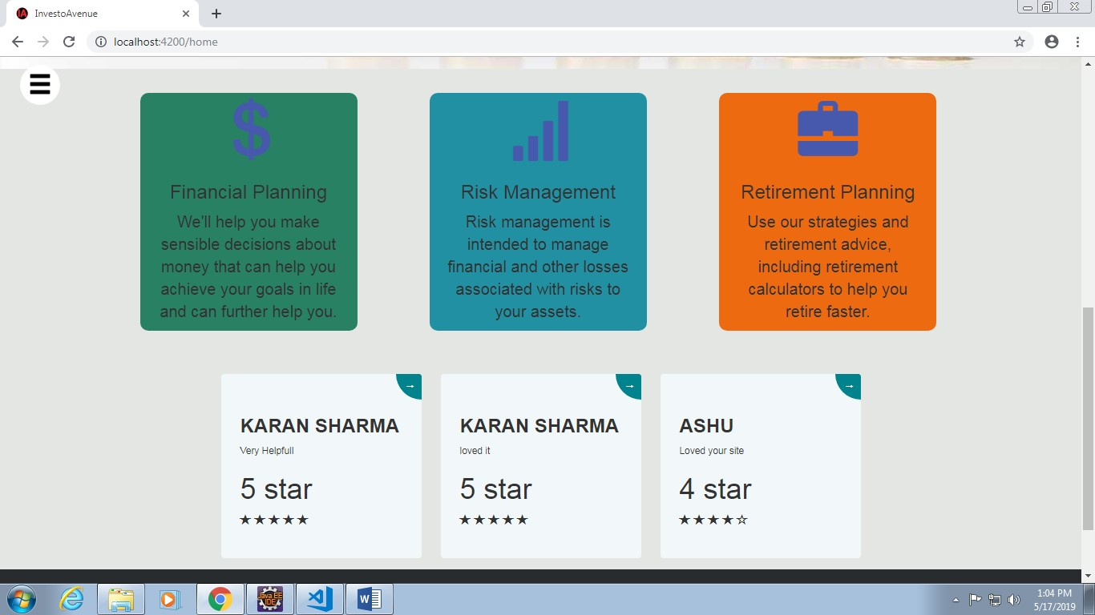

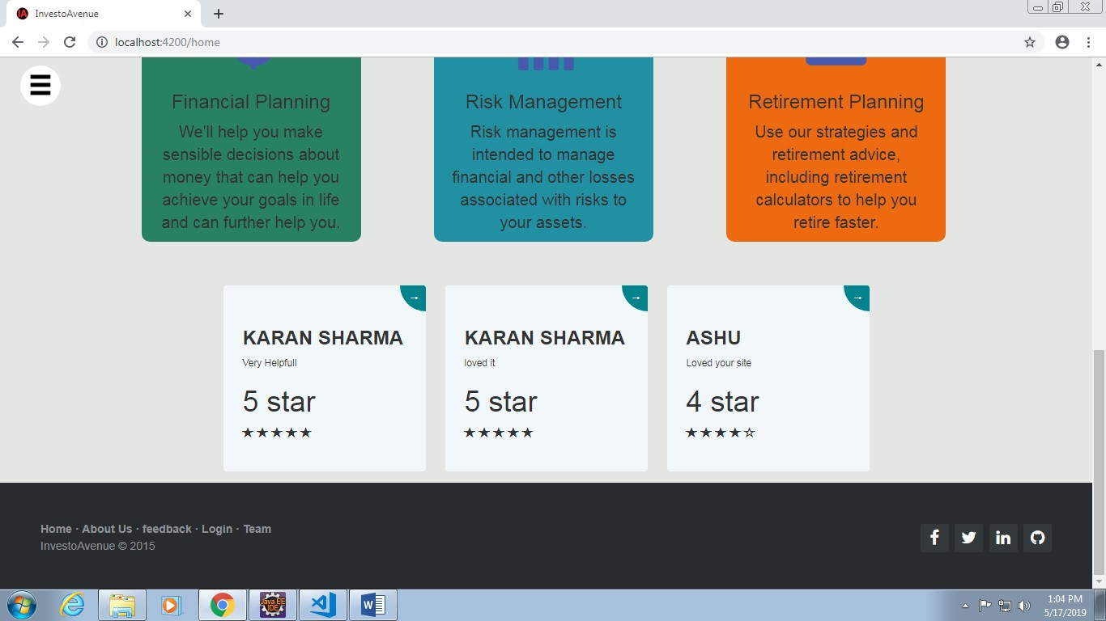

Navigation Bar before Login:

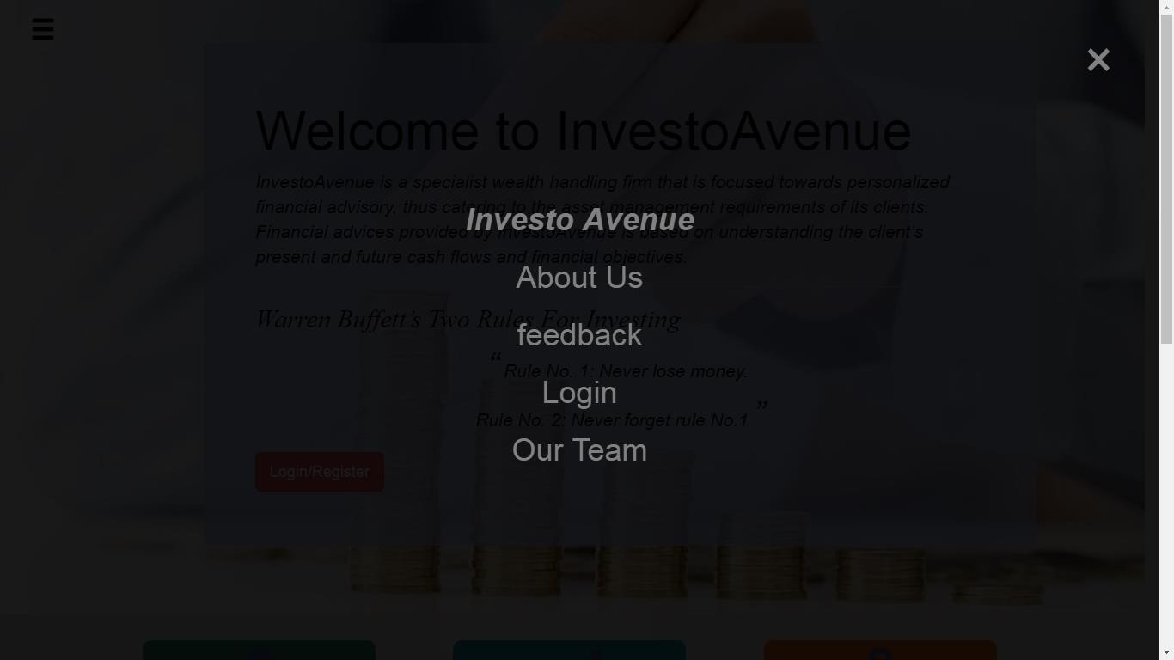

Navigation Bar after login:

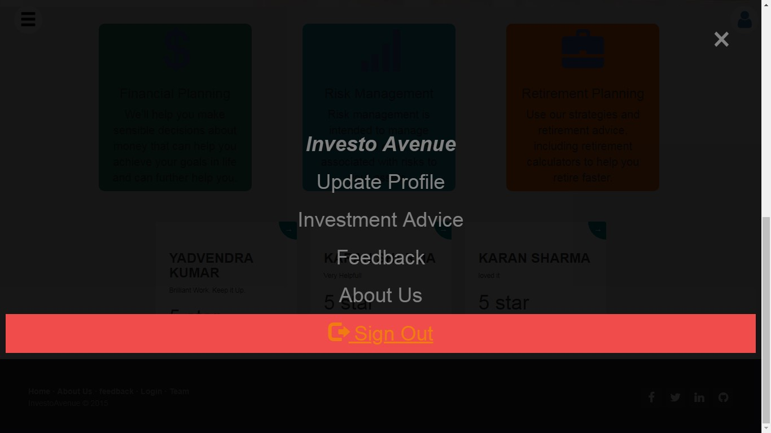

Login-Register: an

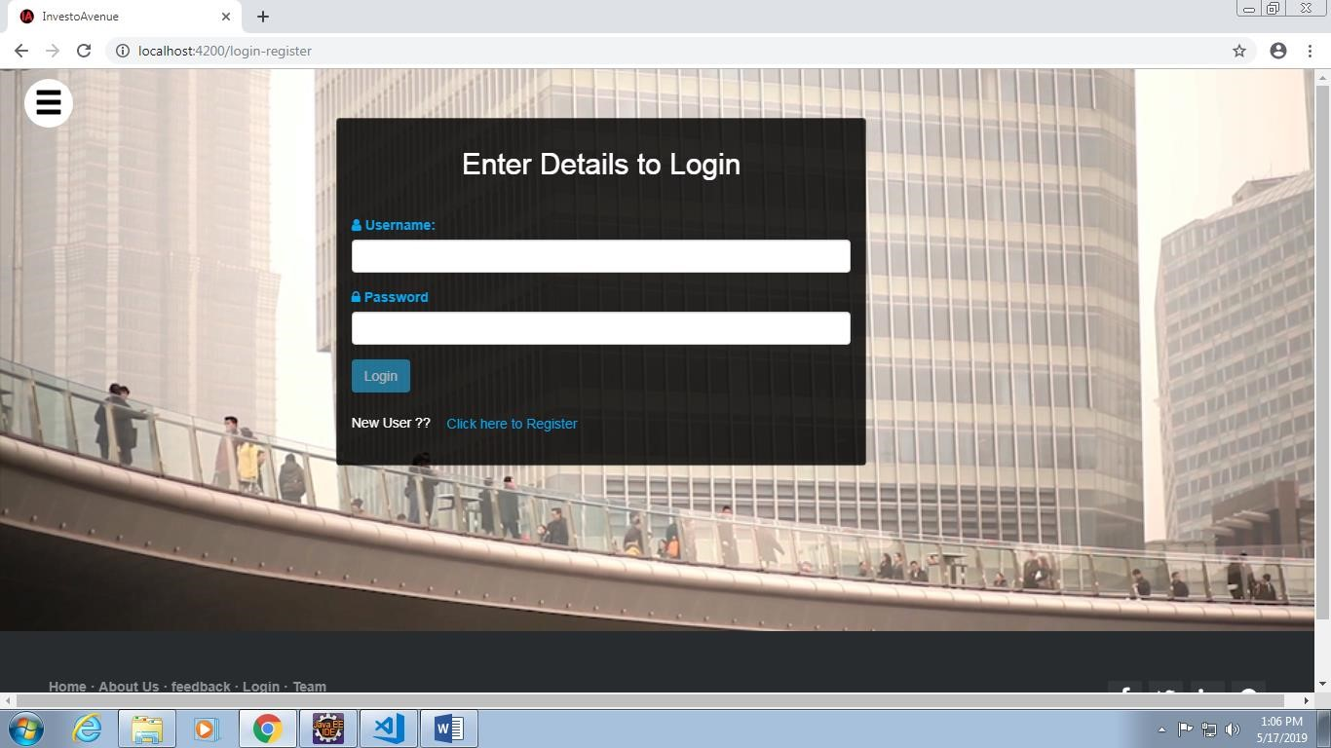

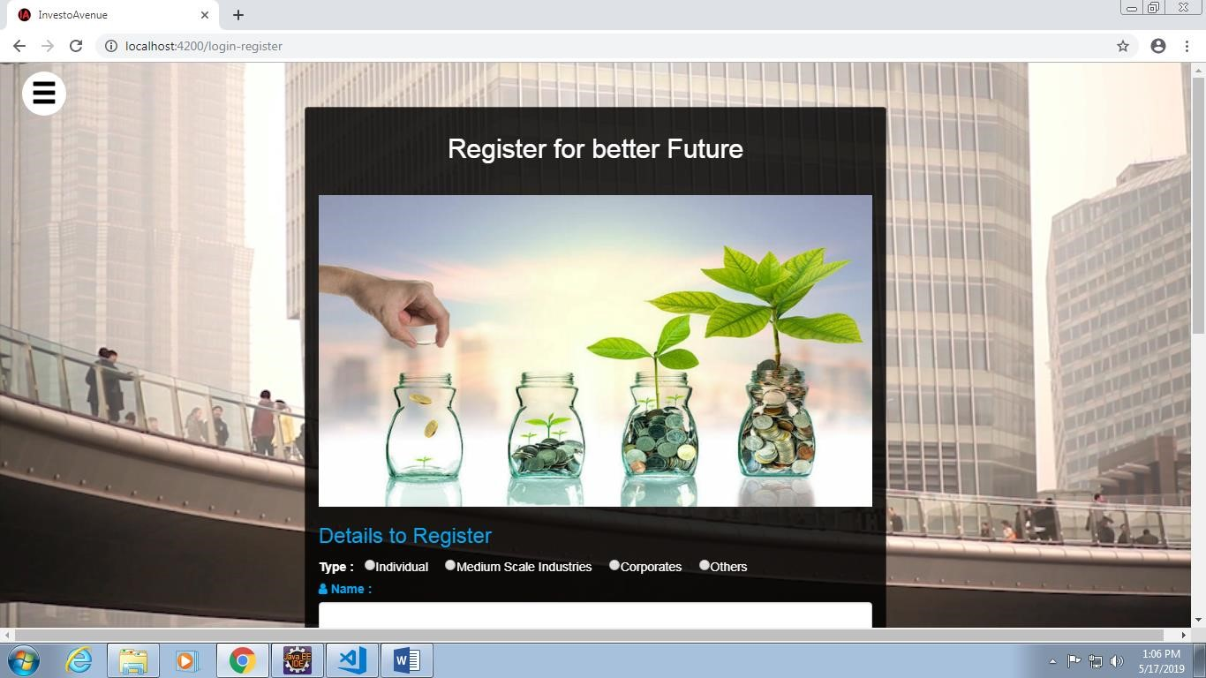

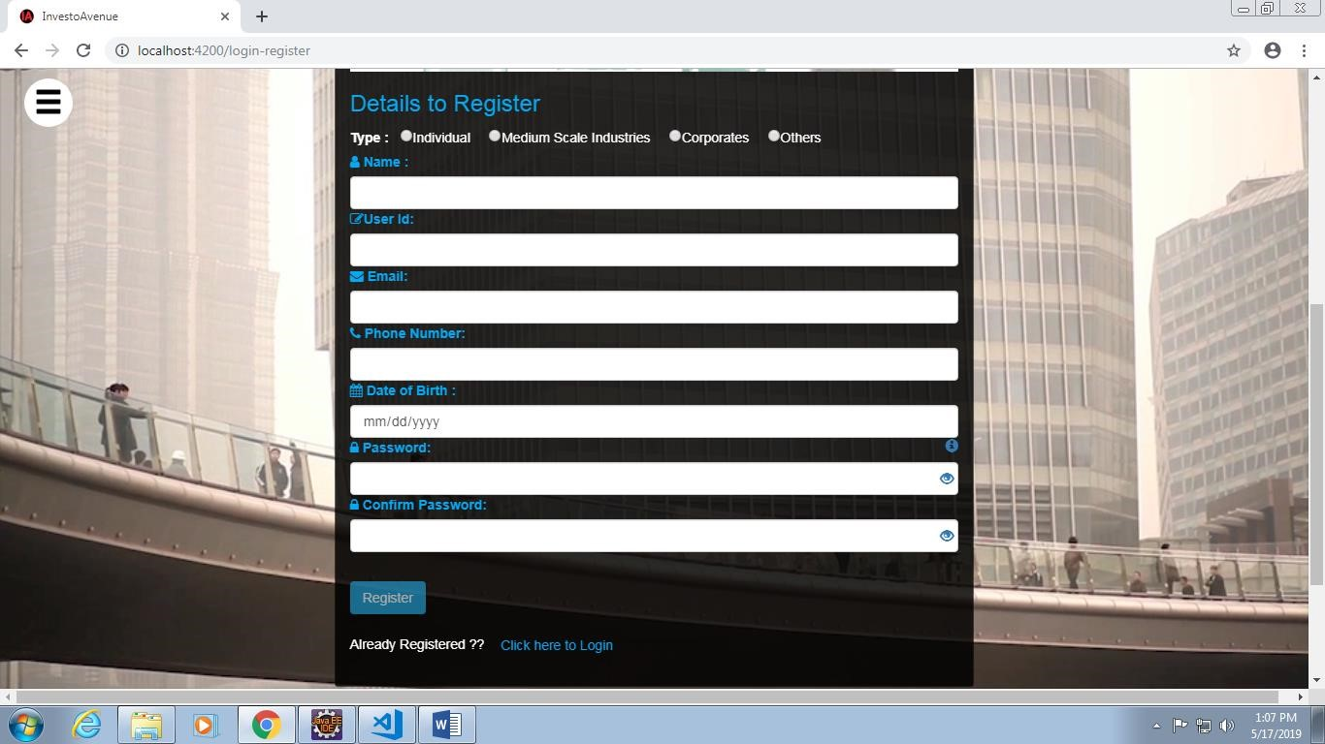

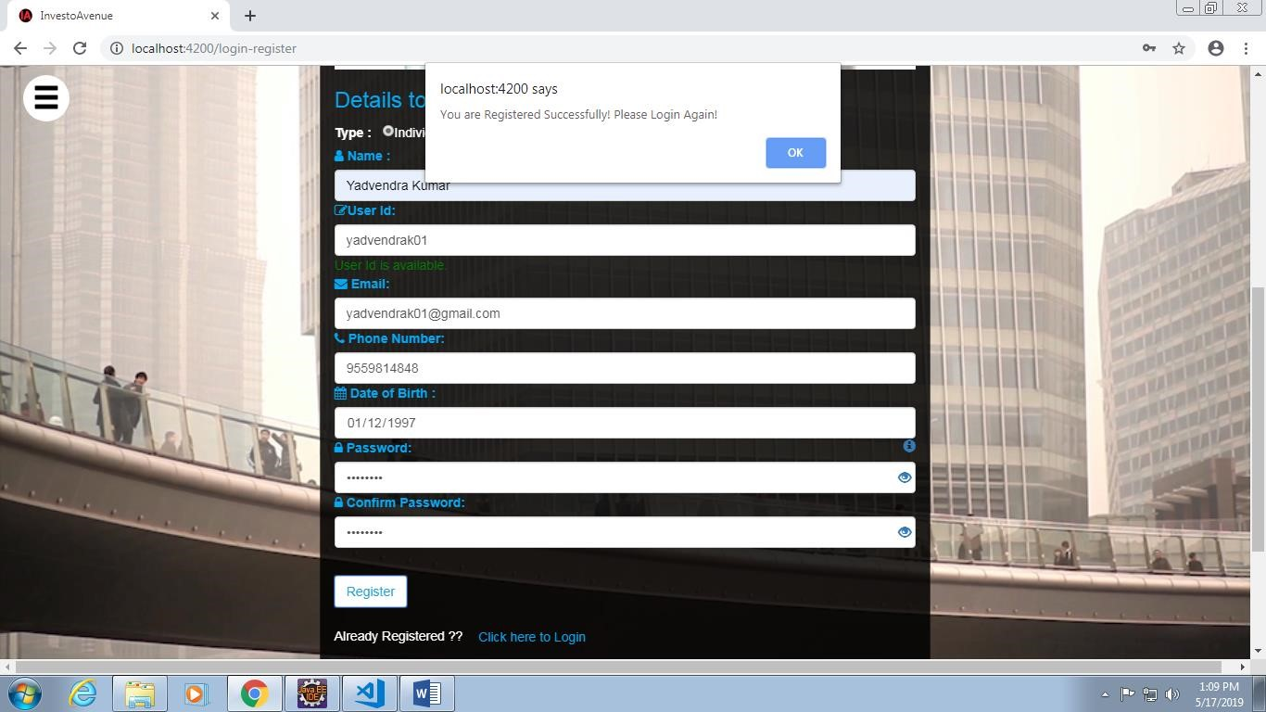

Register-Form Validation :

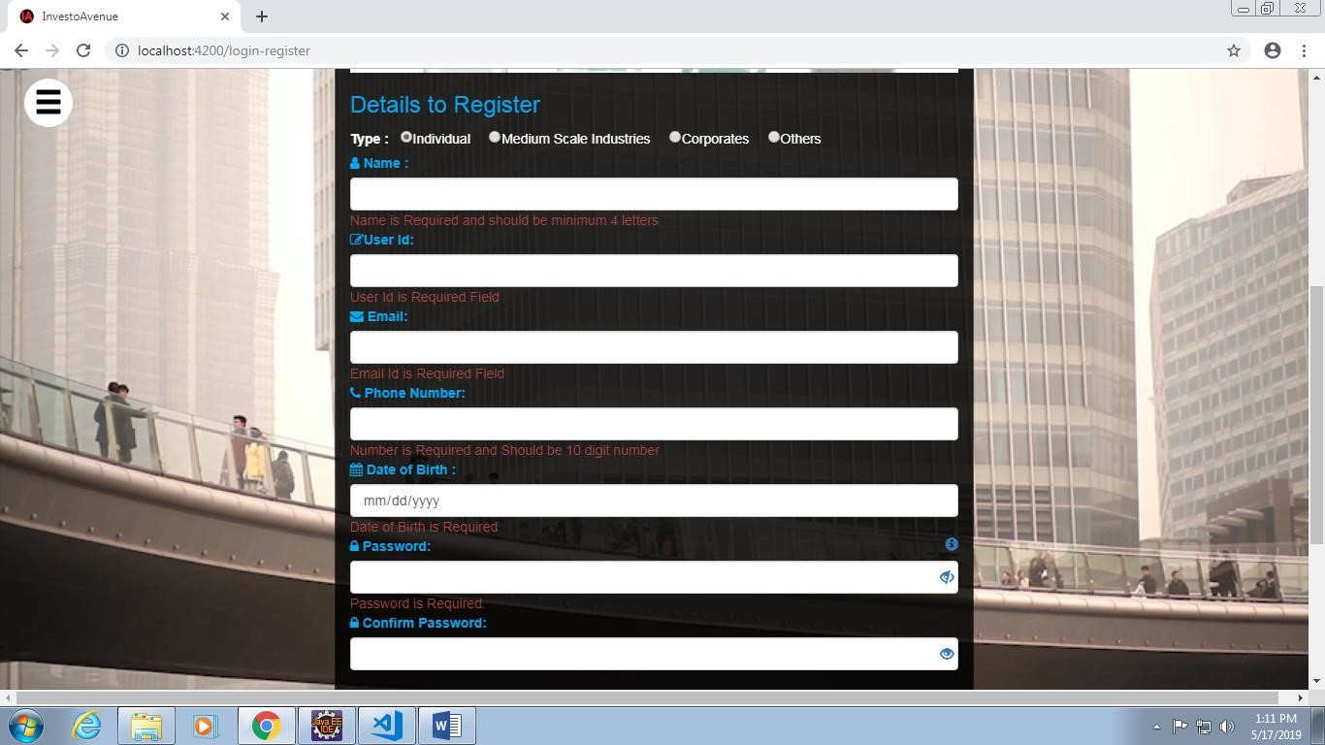

Login Form-Validation:

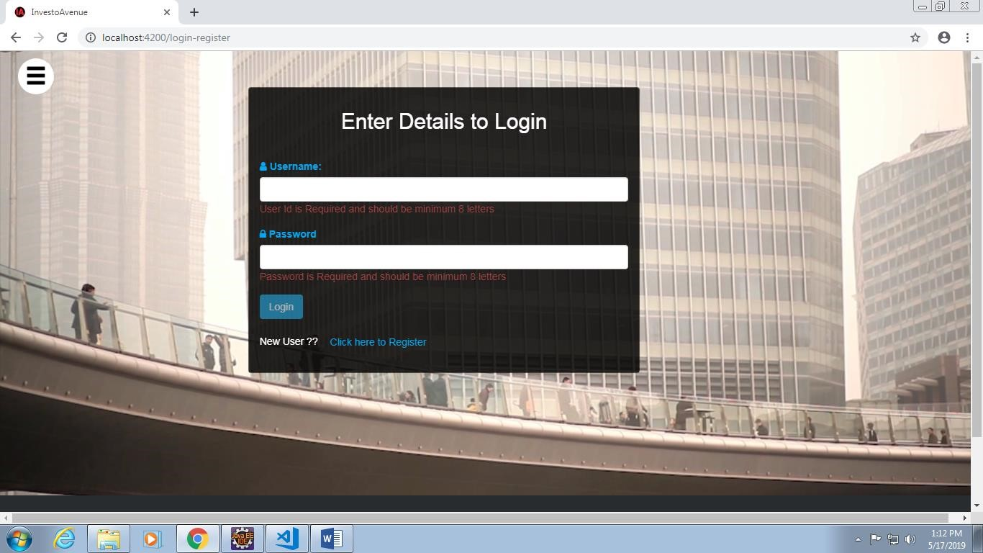

Homepage After Login:

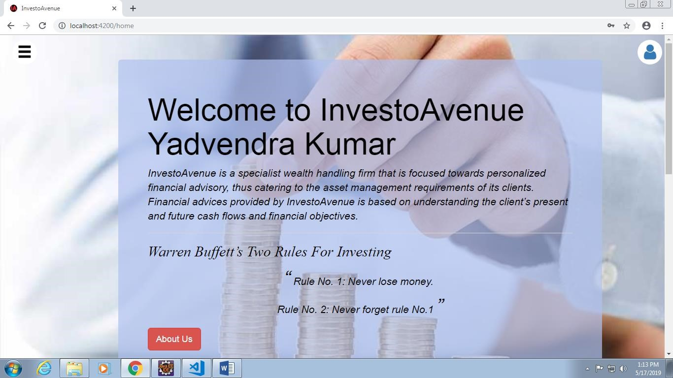

On hovering User Icon:

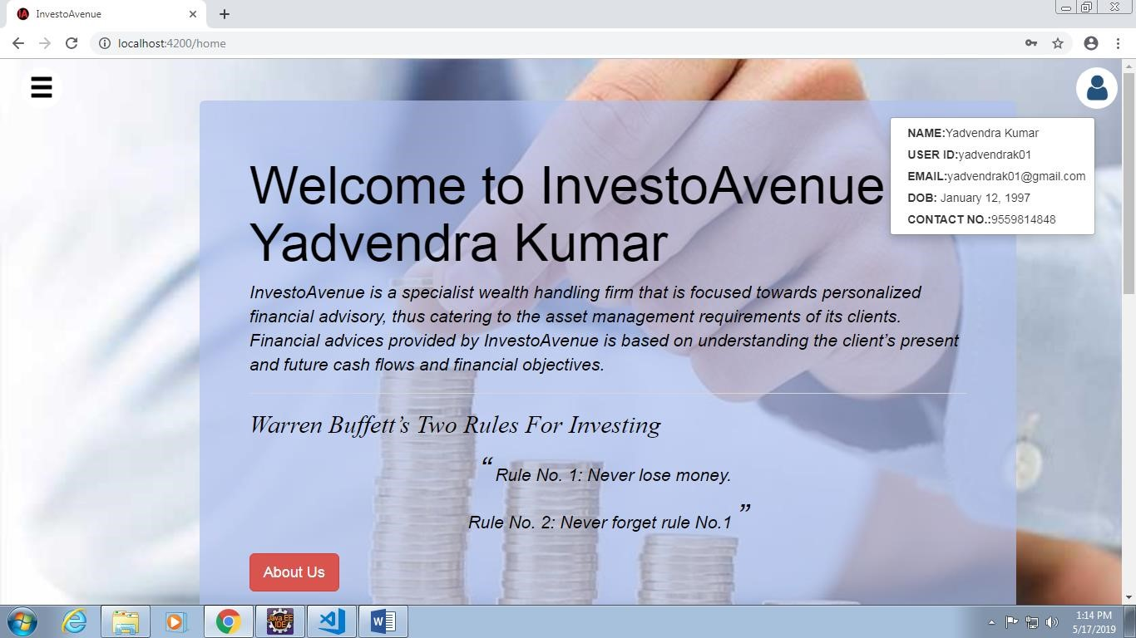

Update-Profile :

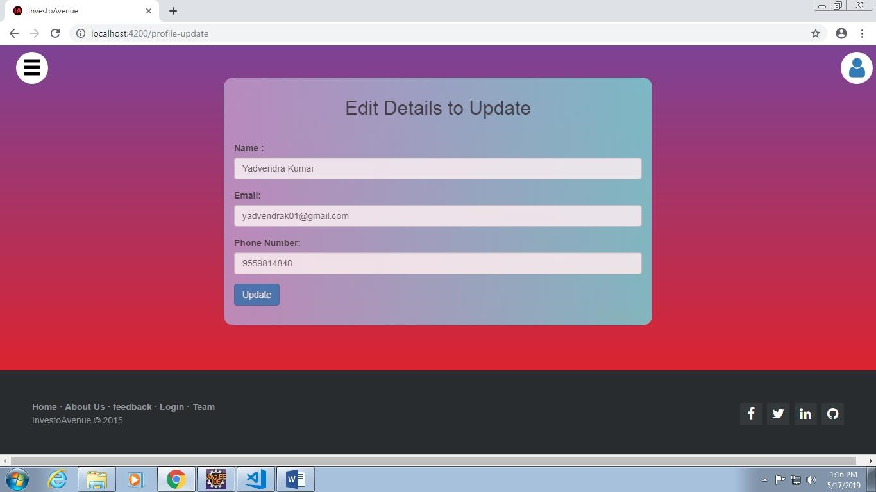

Update-Profile Validations:

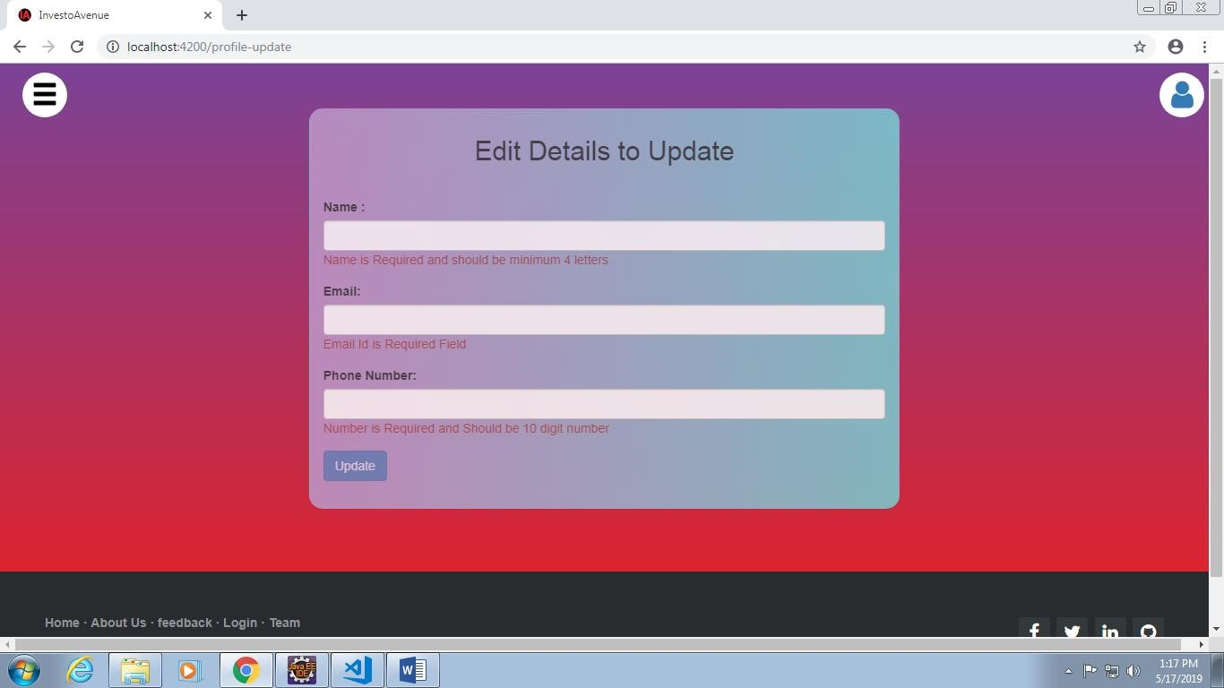

Investment Advice:

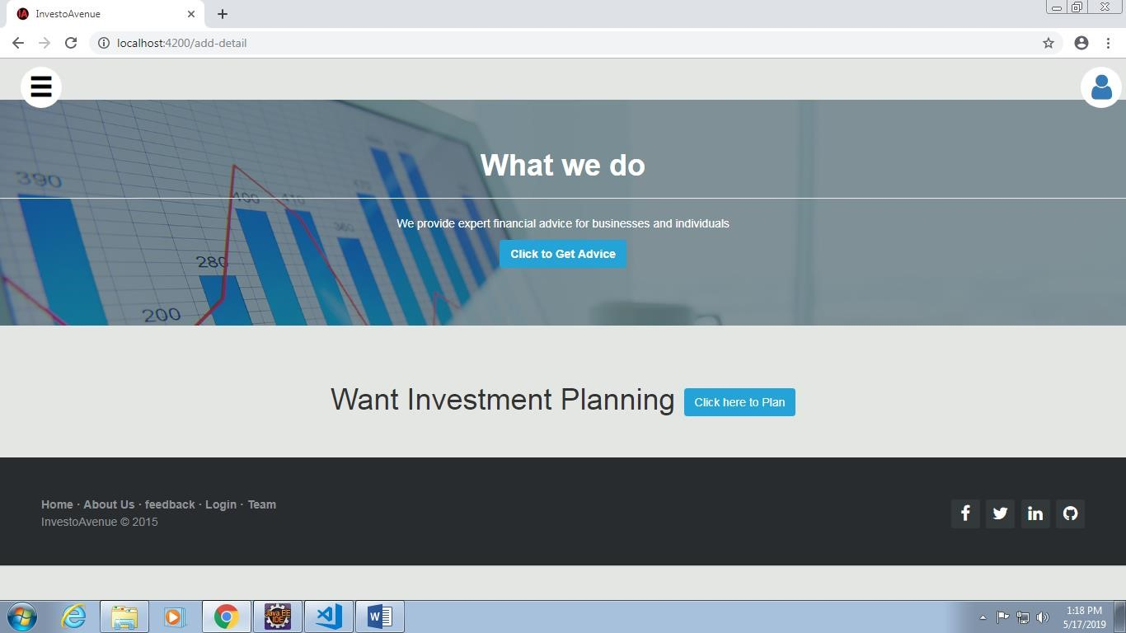

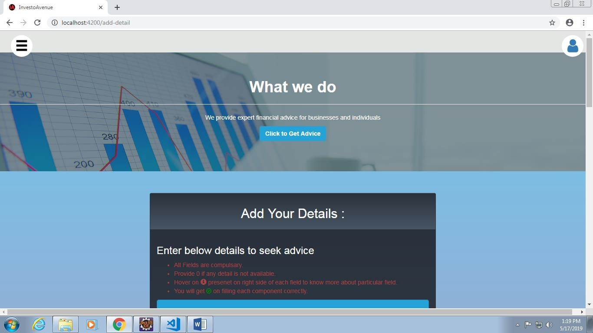

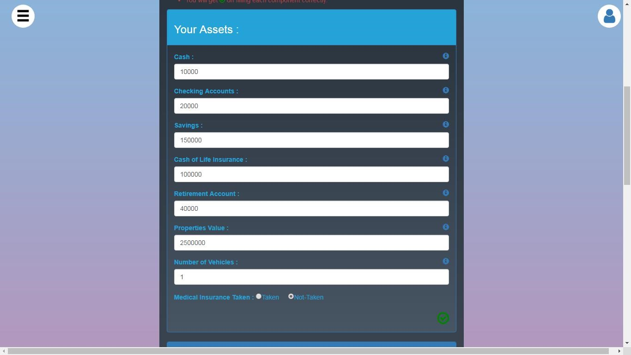

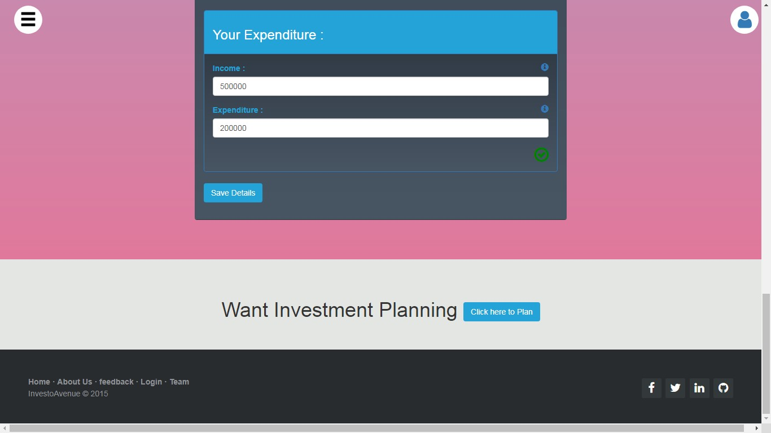

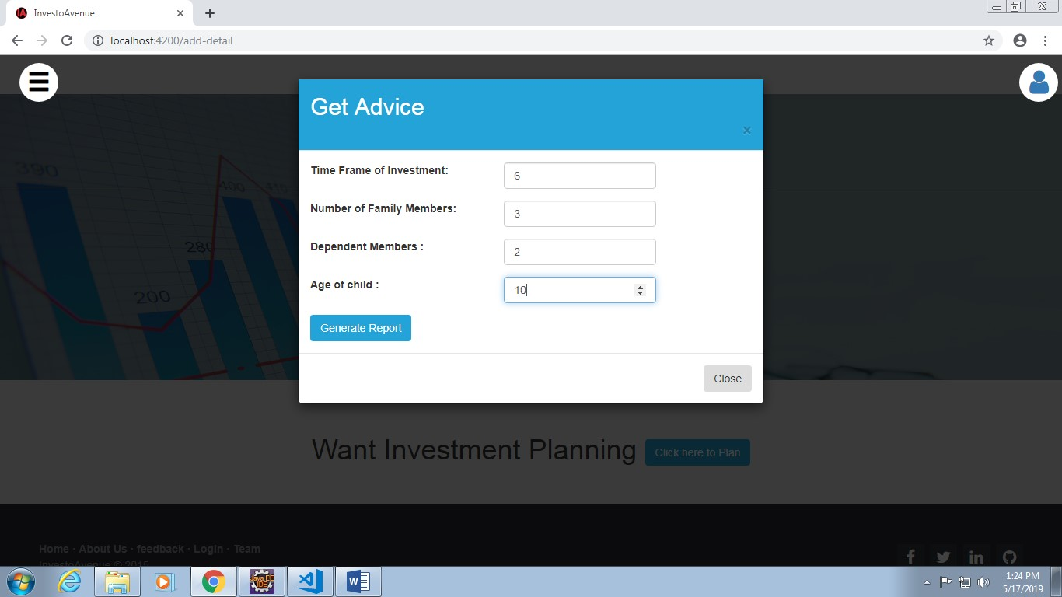

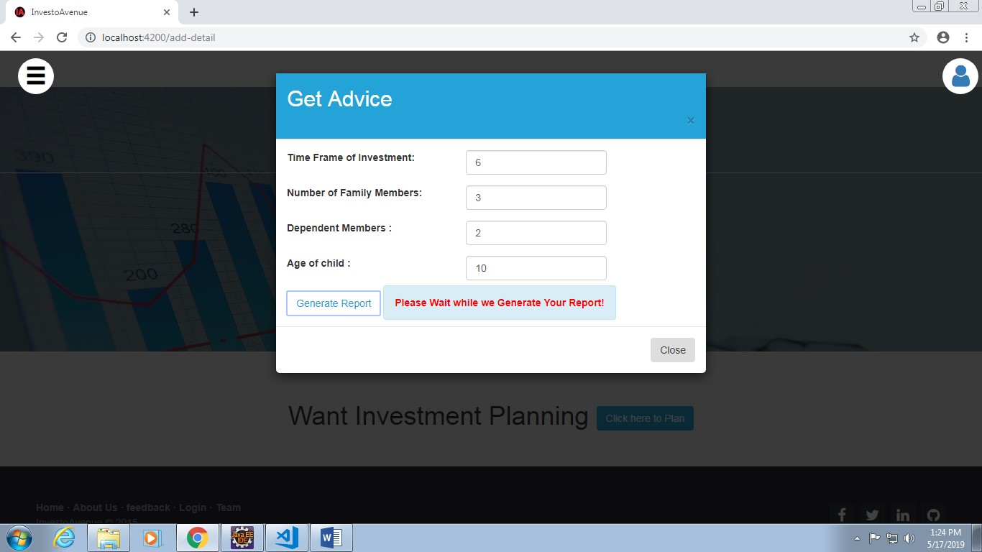

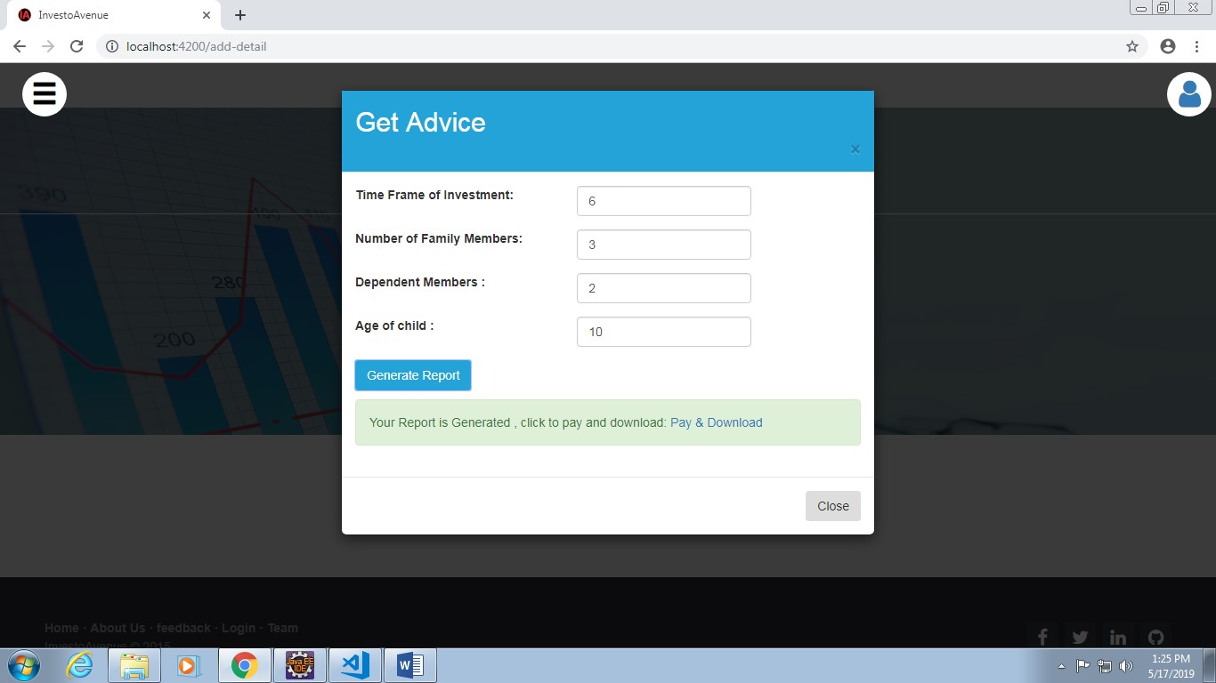

Payment :

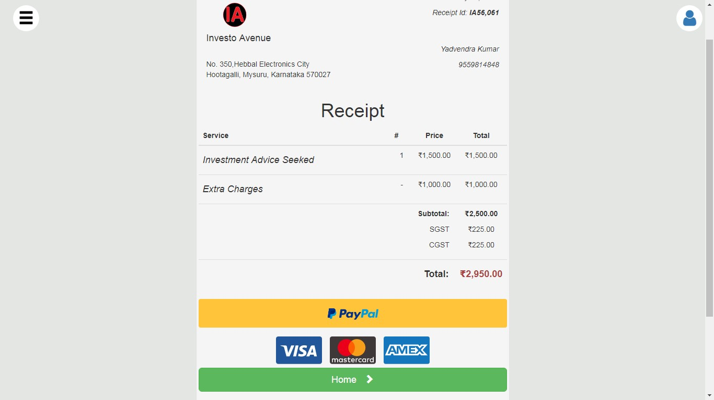

Payment Gateway(PayPal):

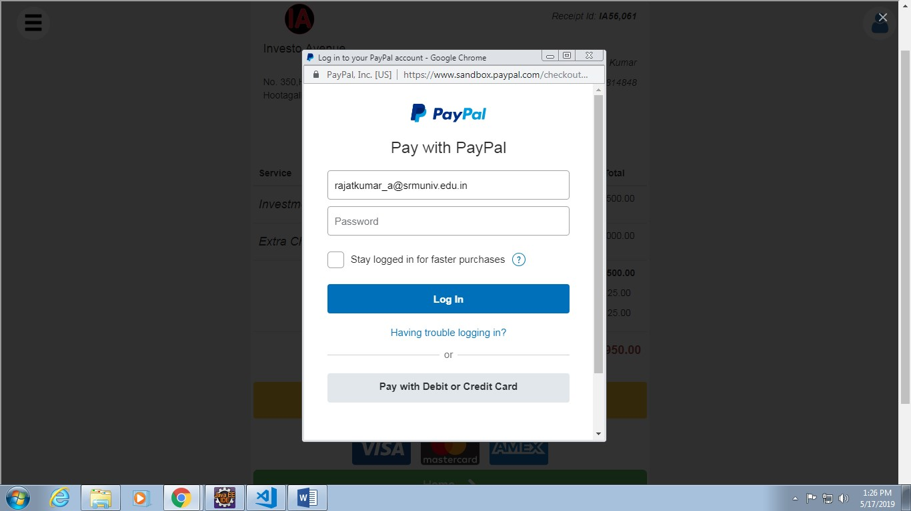

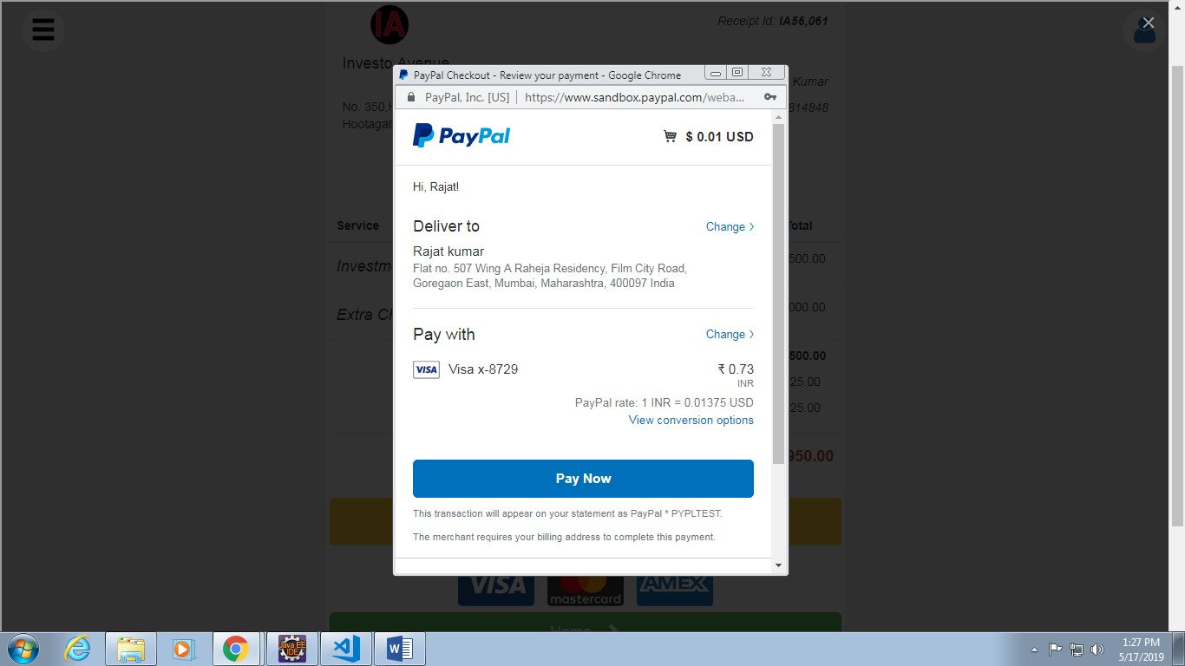

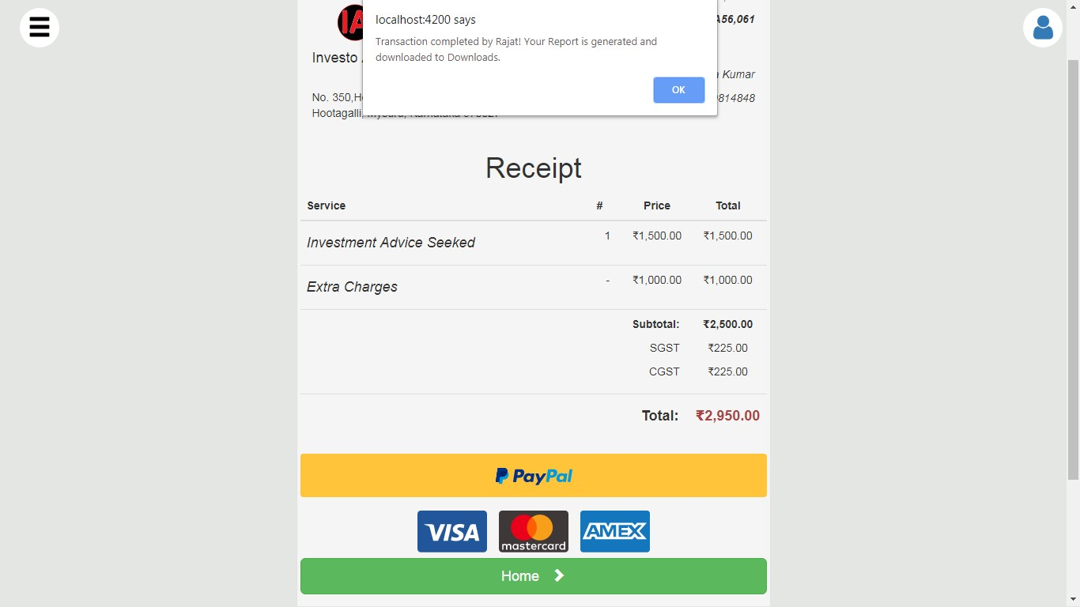

Feedback:

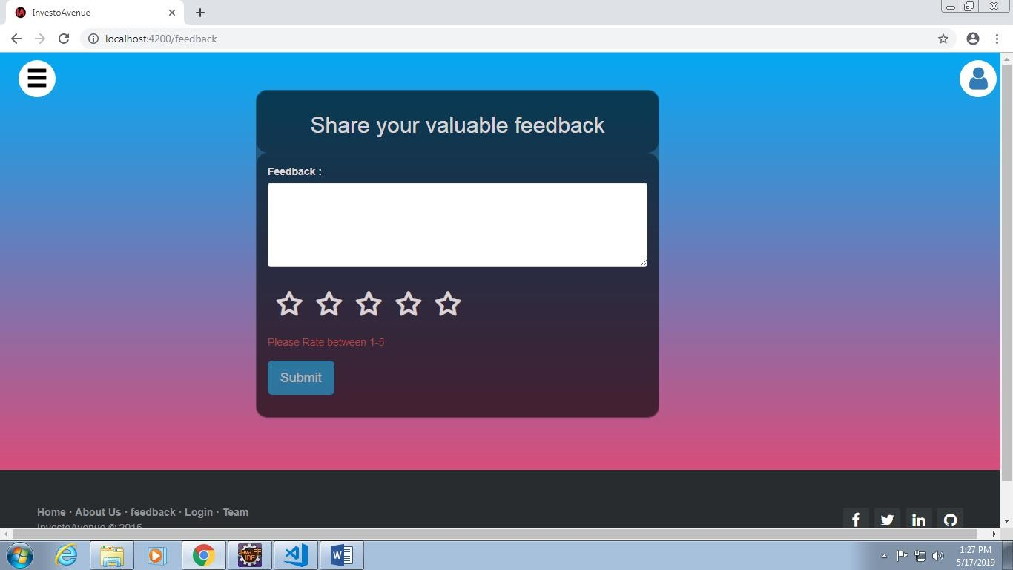

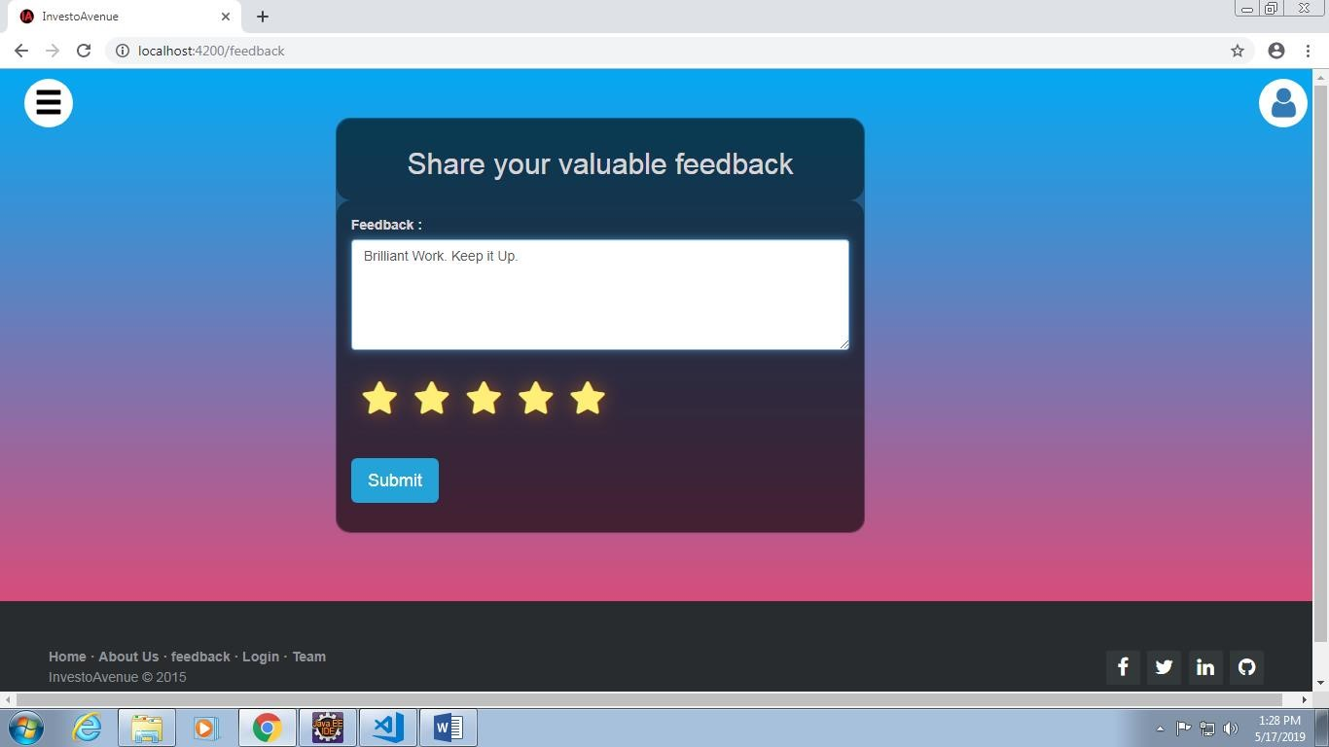

Investment Planner:

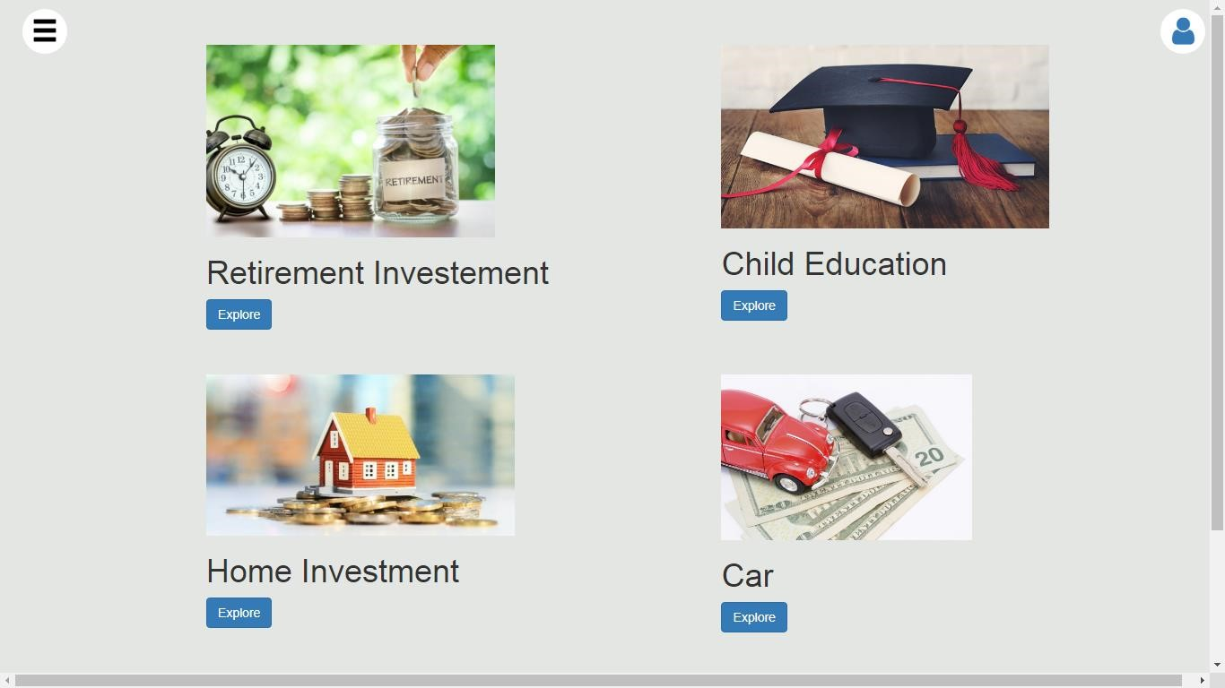

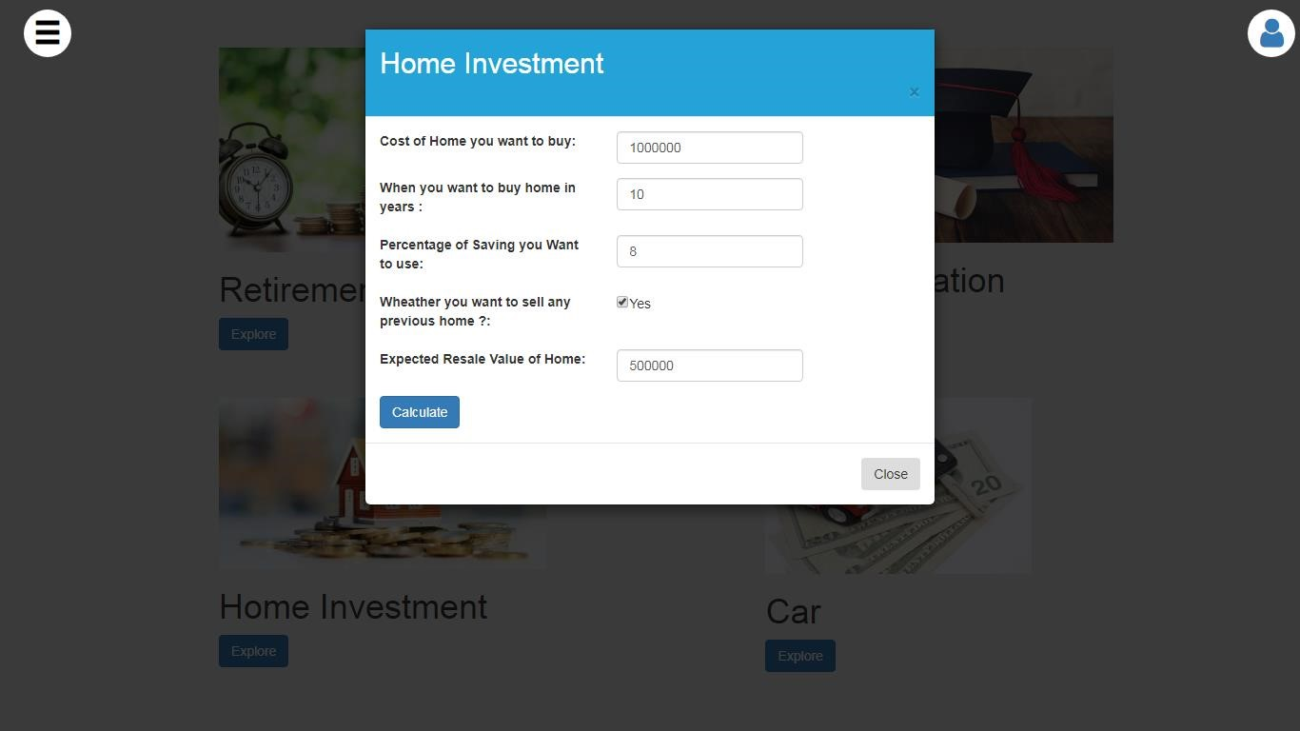

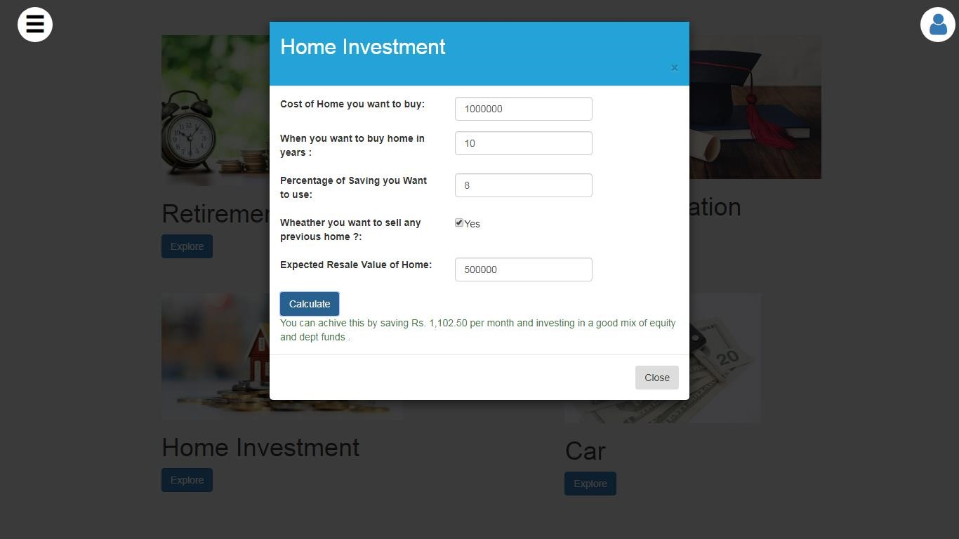

Log Out:

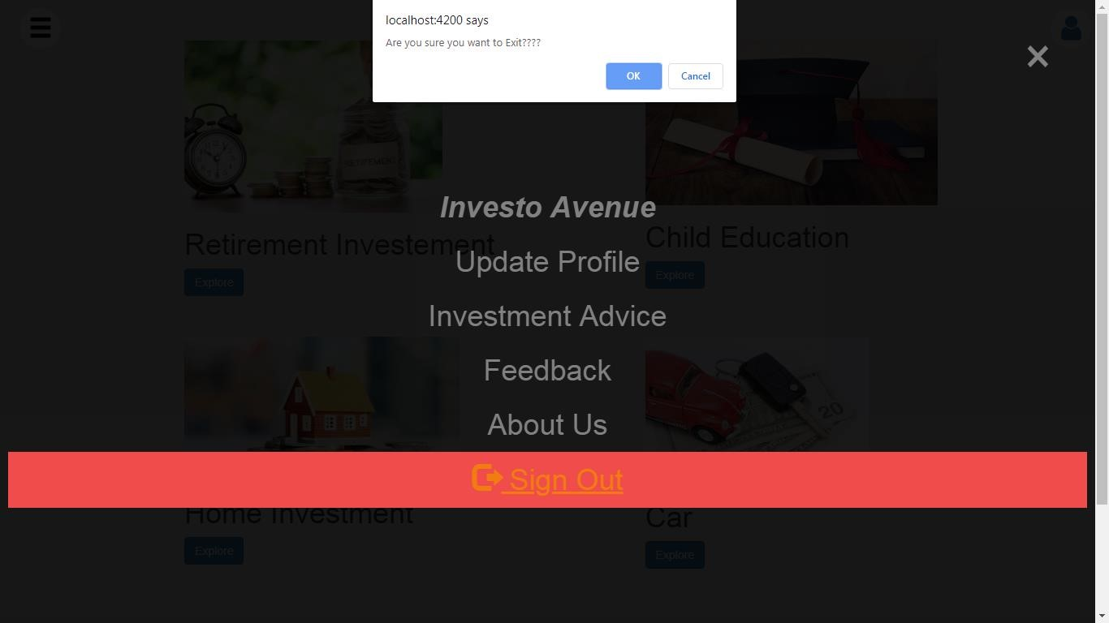

About Us:

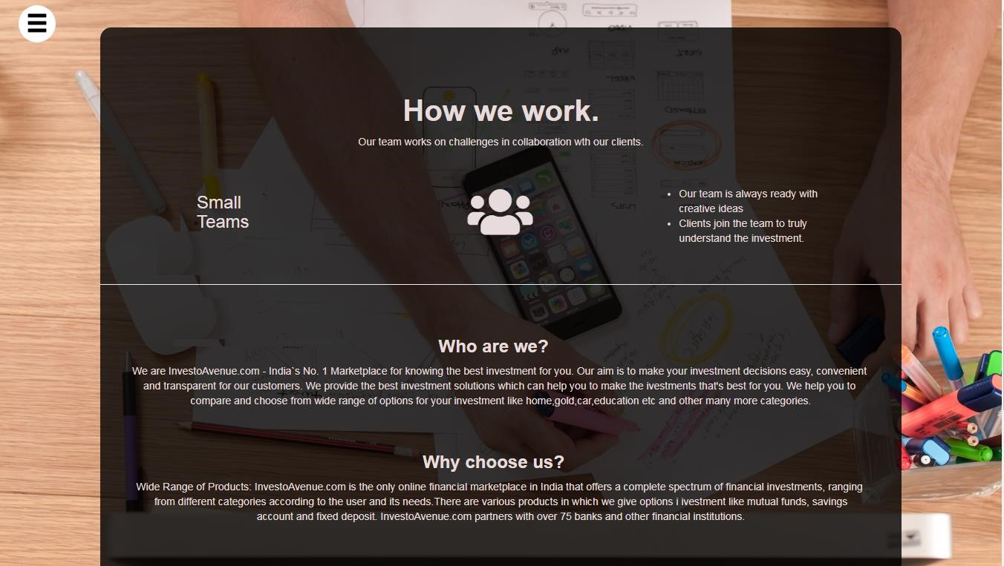

Report (PDF File):



 